**B.M.S. COLLEGE OF ENGINEERING BENGALURU**

Autonomous Institute, Affiliated to VTU





Lab Record

**Object-Oriented Modeling**

*Submitted in partial fulfillment for the 5th Semester Laboratory*

Bachelor of Engineering

in

Computer Science and Engineering

*Submitted by:*

**Harsh Dev**

1BM22CS107

Under the guidance

Department of Computer Science and Engineering

B.M.S. College of Engineering

Bull Temple Road, Basavanagudi, Bangalore 560 019

September-January 2025

**B.M.S. COLLEGE OF ENGINEERING**

**DEPARTMENT OF COMPUTER SCIENCE AND ENGINEERING**



***CERTIFICATE***

This is to certify that the Object-Oriented Modelling(23CS5PCOOM) laboratory has been carried out by Harsh Dev (1BM22CS107) during the 5th Semester Sep 24- Jan2025.

Signature of the Faculty Incharge:

Spoorthi DM

Department of Computer Science and Engineering

B.M.S. College of Engineering, Bangalore

**Table Of Contents**

|  |  |  |
| --- | --- | --- |
| **Sl.no.** | **Experiment Title** | **Page no.** |
| **1.** | **System Requirements Specifications** |  |
| **2.** | **Class Modelling** |  |
| **3.** | **State Modelling** |  |
| **4.** | **Interaction Modelling: Use Case Models** |  |
| **5.** | **Interaction Modelling: Sequence Models** |  |
| **6.** | **Interaction Modelling: Activity Models** |  |

1. **SOFTWARE REQUIREMENTS SPECIFICATIONS (SRS)**

**Hotel Management System**

**Problem Statement:**

Hotels often struggle with managing guest reservations, room availability, check-ins/outs, and billing manually. This leads to inefficiencies, overbookings, and potential customer dissatisfaction. The need exists for a Hotel Management System that automates these processes, ensuring accurate tracking of bookings, efficient room management, and seamless billing.

**1. Introduction:**

* **1.1 Purpose:**  
  The purpose of this document is to provide a detailed SRS for the Hotel Management System (HMS). This system will automate the management of hotel operations like room booking, check-ins/outs, and billing.
* **1.2 Scope:**  
  The HMS will reduce manual labor and improve efficiency. It will be accessible by hotel staff and management, ensuring faster customer service and accurate financial tracking. The development will require 3 months and an estimated budget of $30,000.
* **1.3 Overview:**  
  HMS will provide a complete solution for hotel management, handling room inventory, guest details, billing, and reporting.

**2. General Description:**  
The system will be used by hotel staff and management. It will have a user-friendly interface, allowing staff to check room availability, manage bookings, and process payments.

**3. Functional Requirements:**

* Room booking, check-in, and check-out system.
* Manage customer details and billing.
* Generate financial and occupancy reports.

**4. Interface Requirements:**  
Graphical user interface (GUI) for hotel staff, with database integration for storing customer and room data.

**5. Performance Requirements:**  
The system must handle up to 100 simultaneous users without performance degradation, processing room availability checks within 2 seconds.

**6. Design Constraints:**  
The system must integrate with existing hotel security and camera systems for room monitoring.

**7. Non-Functional Attributes:**

* Security for customer data.
* Reliable and scalable architecture.

**8. Preliminary Schedule and Budget:**  
Development will take 3 months, with an estimated cost of $30,000.

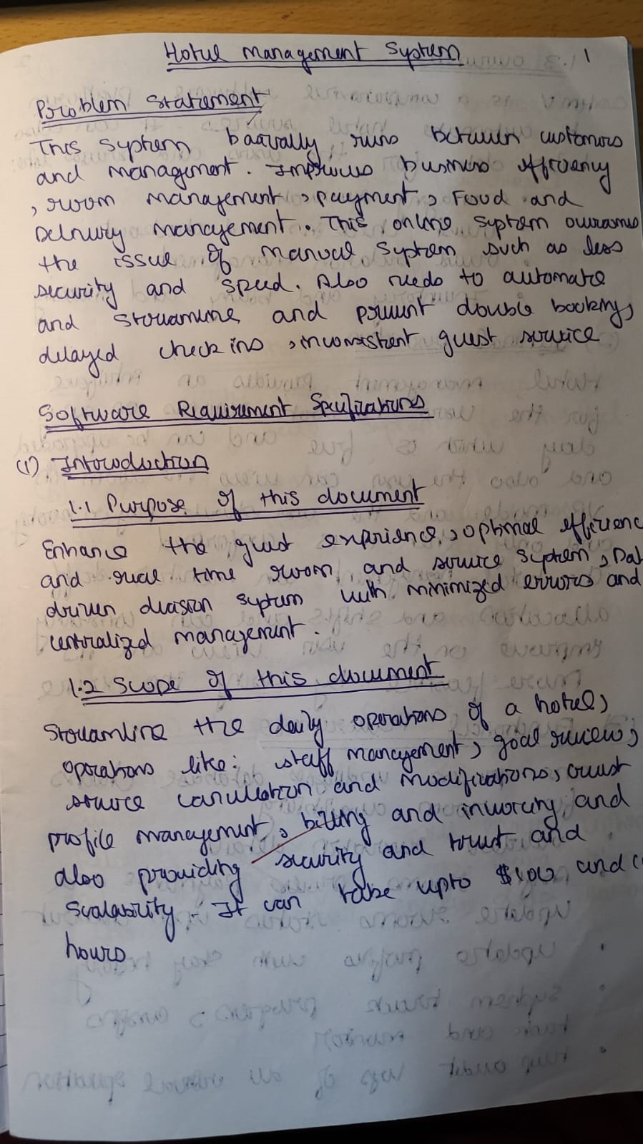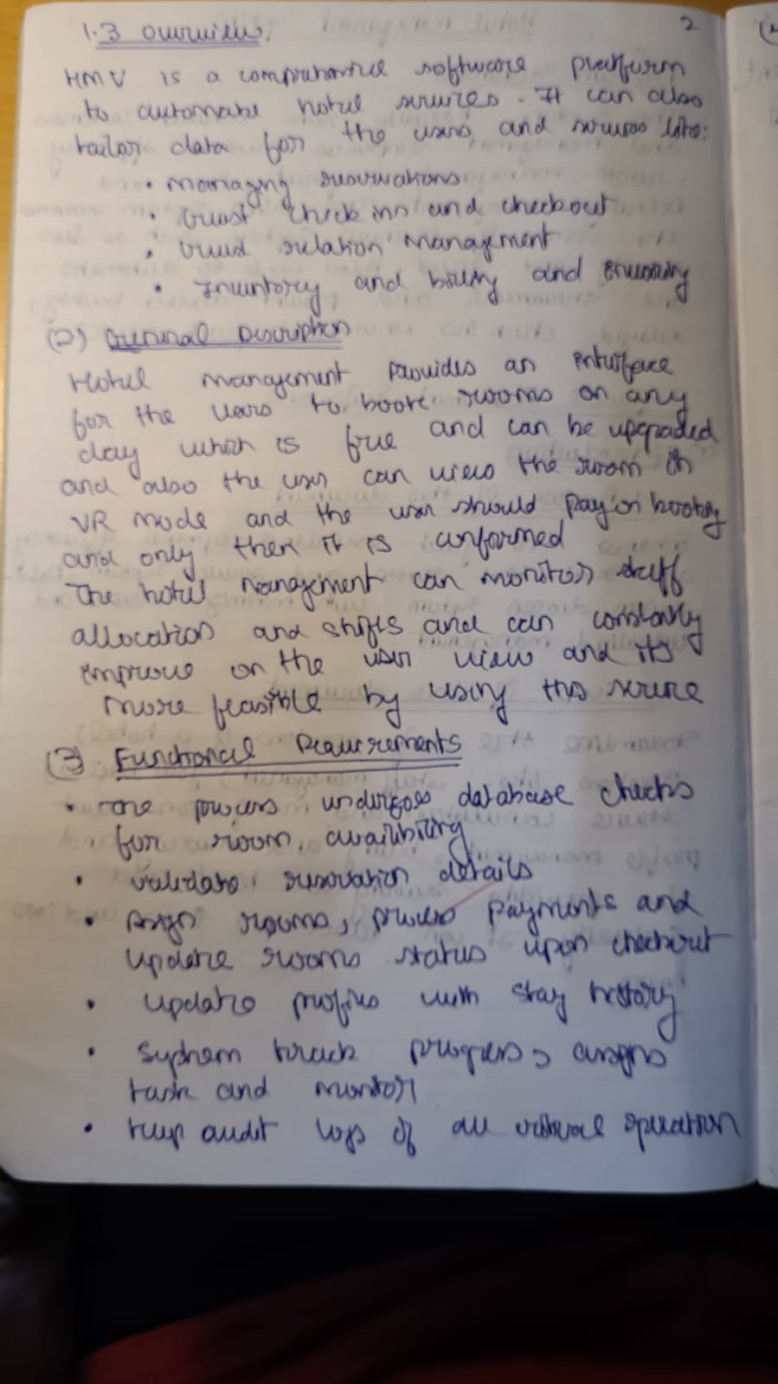

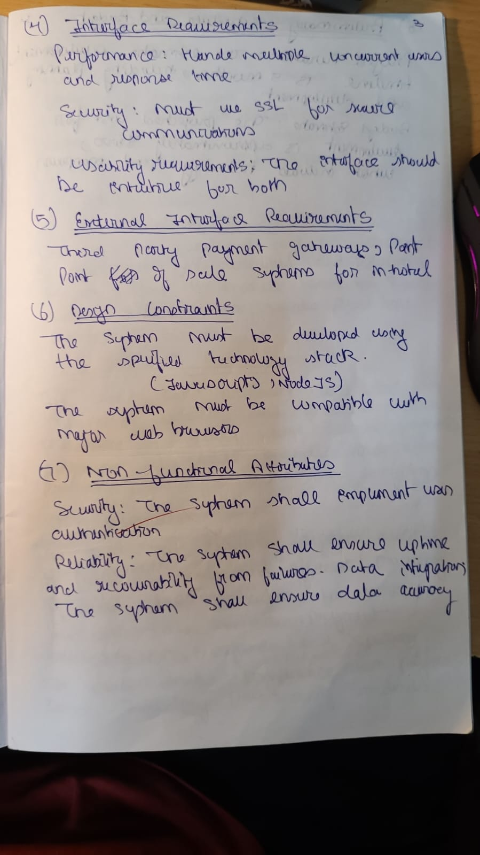

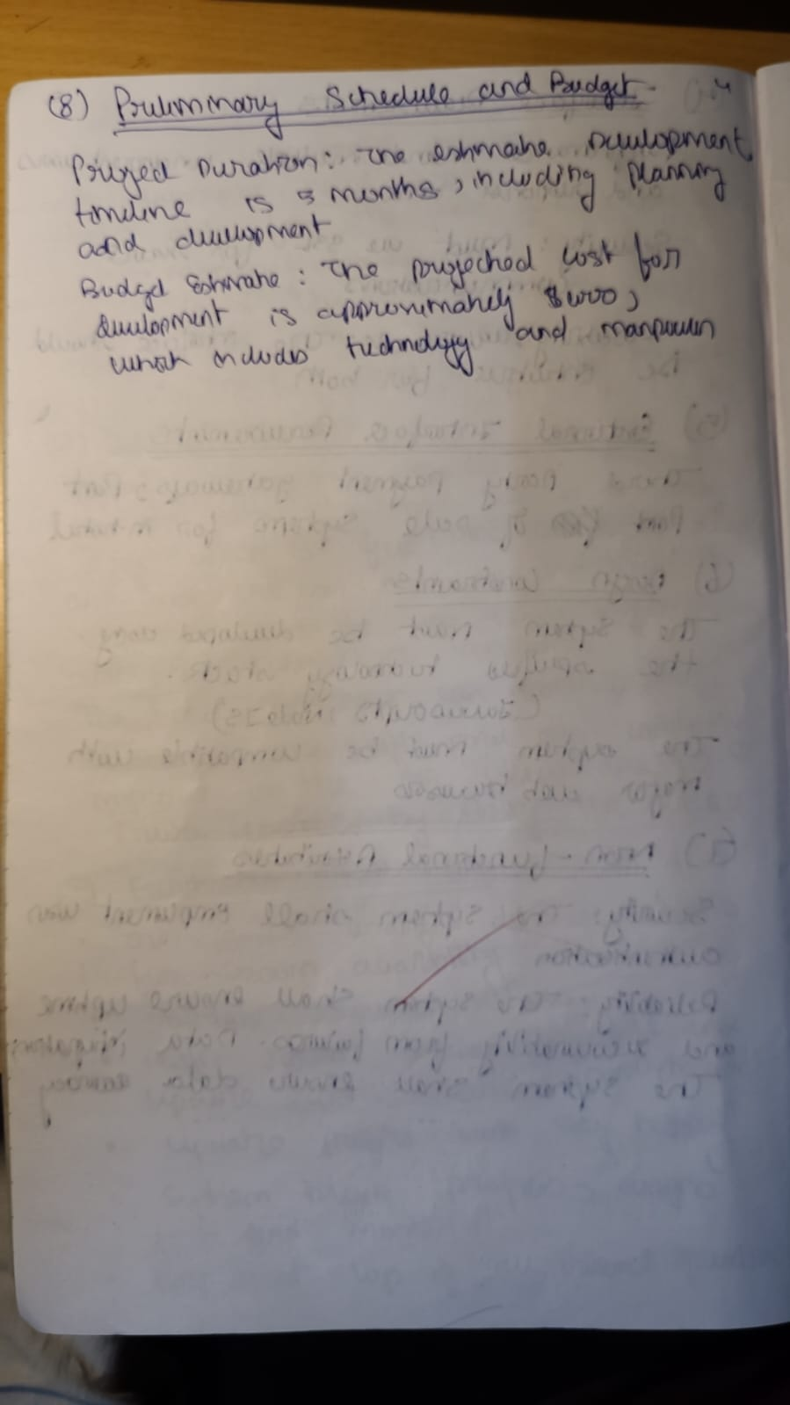

**Credit Card Processing System**

**Problem Statement:**

Businesses face challenges in securely processing credit card transactions while ensuring speed and accuracy. Without proper fraud detection mechanisms and secure data handling, companies risk financial losses and compromised customer information. A robust Credit Card Processing System is required to handle transactions securely, detect potential fraud, and provide a fast, reliable user experience.

**1. Introduction:**

* **1.1 Purpose:**  
  This document defines the SRS for a Credit Card Processing System (CCPS), designed to facilitate secure credit card transactions.
* **1.2 Scope:**  
  The CCPS will allow businesses to process credit card payments with integrated fraud detection and transaction history tracking. Development will take 4 months with a budget of $40,000.
* **1.3 Overview:**  
  The system will offer secure processing of credit card transactions, reduce fraud risks, and provide reporting tools.

**2. General Description:**  
The system will be used by merchants and customers to process payments. It will ensure safe and fast transactions.

**3. Functional Requirements:**

* Secure credit card processing (charge, refund, etc.).
* Transaction history and reporting.

**4. Interface Requirements:**  
The system will interface with bank APIs for transaction validation and fraud detection.

**5. Performance Requirements:**  
It must process each transaction in less than 3 seconds with a 99.99% uptime.

**6. Design Constraints:**  
Must comply with PCI-DSS standards for secure payment processing.

**7. Non-Functional Attributes:**

* High security.
* Scalability to handle peak transaction loads.

**8. Preliminary Schedule and Budget:**  
Development is estimated at 4 months with a budget of $40,000

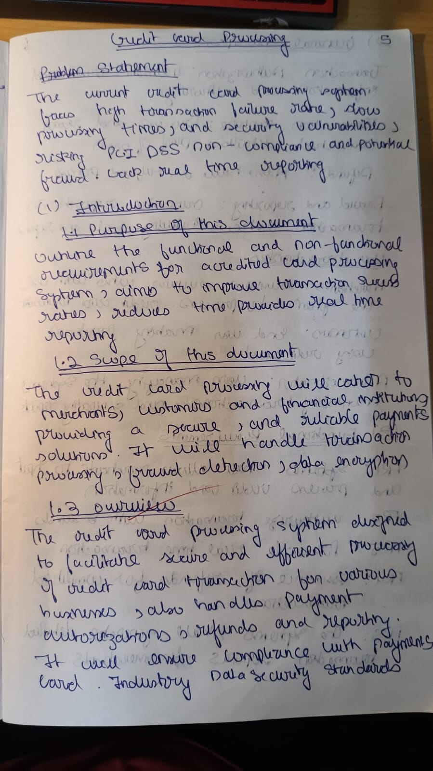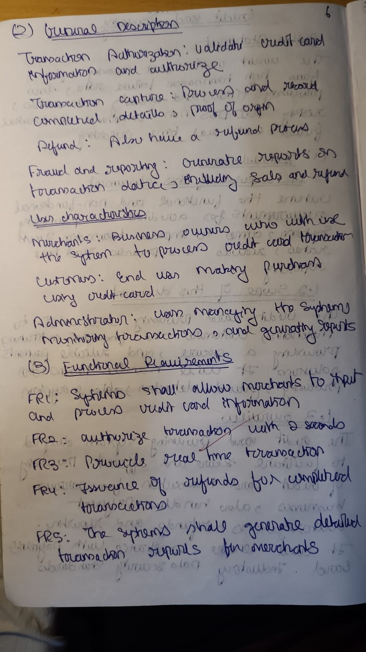

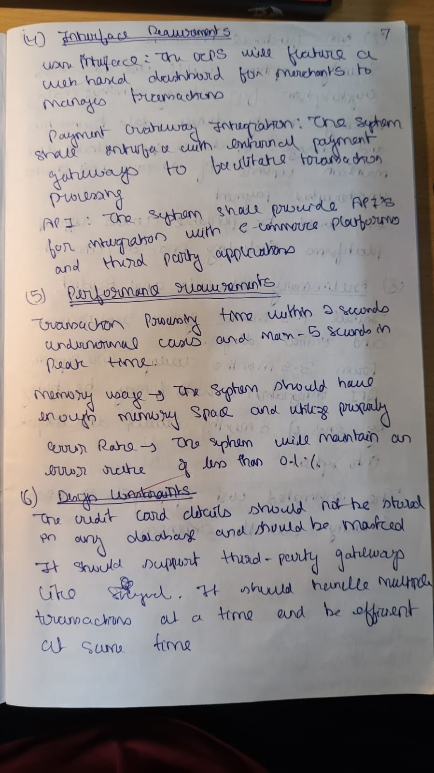

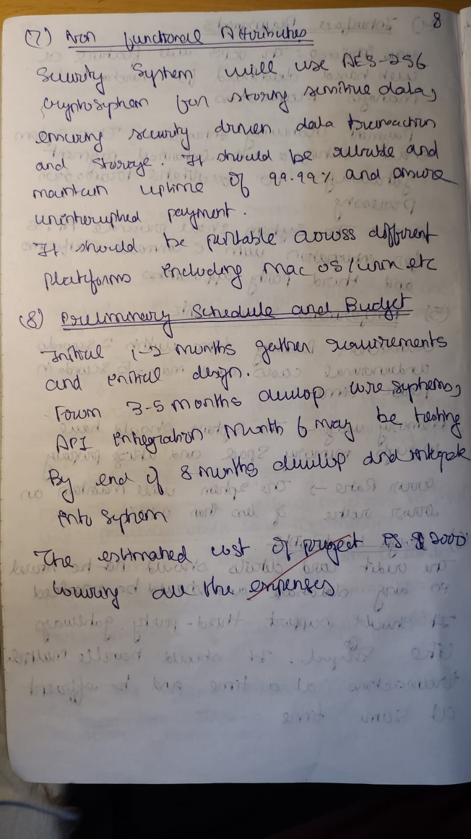

**Library Management System**

**Problem Statement:**

Manual tracking of library books, loans, and returns is time-consuming and prone to errors, leading to lost books and inefficient member services. The lack of an automated system results in delays and errors in managing book circulation and overdue fines. There is a need for a Library Management System to automate book cataloging, track borrowing and returning of books, and manage fines efficiently.

**1. Introduction:**

* **1.1 Purpose:**  
  This document describes the SRS for the Library Management System (LMS), automating book lending and cataloging.
* **1.2 Scope:**  
  The LMS will allow librarians to manage book inventory and track borrowing. The development will take 2 months with a budget of $20,000.
* **1.3 Overview:**  
  The LMS will facilitate book borrowing, returning, and inventory management for libraries.

**2. General Description:**  
The system will be used by librarians and members for book cataloging and loan management.

**3. Functional Requirements:**

* Book cataloging and search functionality.
* Borrowing and returning management.

**4. Interface Requirements:**  
GUI for librarians and members, with database integration for tracking books.

**5. Performance Requirements:**  
The system must process book transactions within 1 second.

**6. Design Constraints:**  
Integration with external book databases may be required.

**7. Non-Functional Attributes:**

* User-friendly interface.
* Secure and scalable architecture.

**8. Preliminary Schedule and Budget:**  
Development will take 2 months with a budget of $20,000.

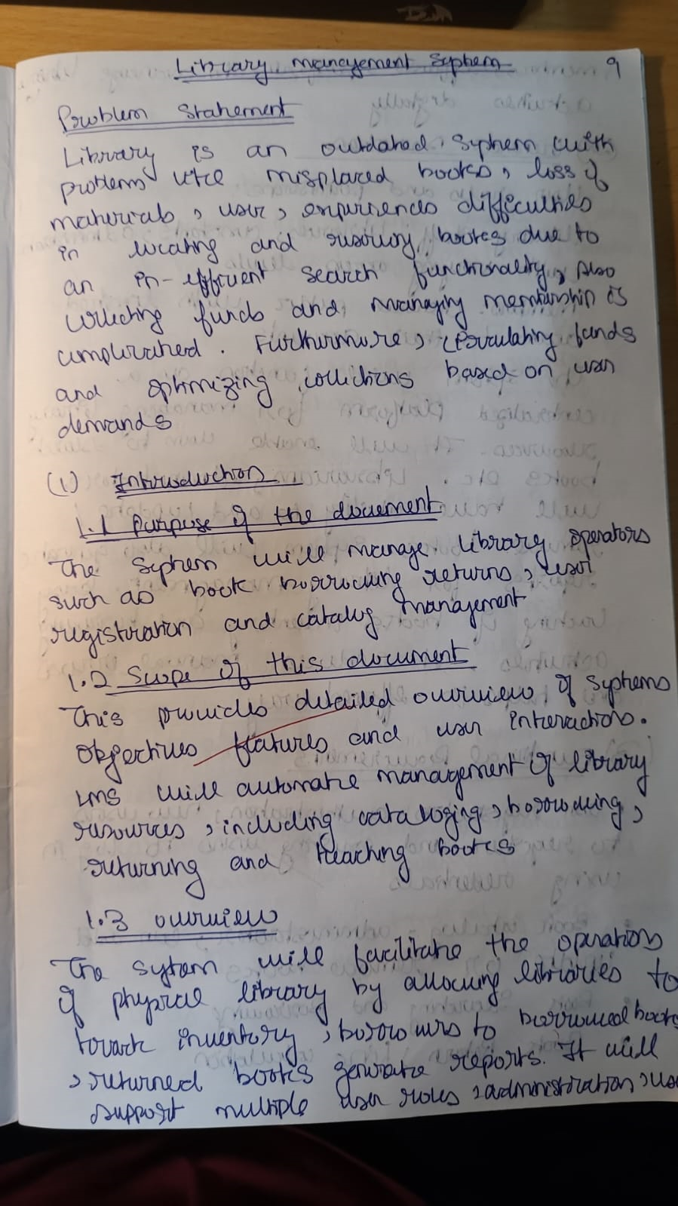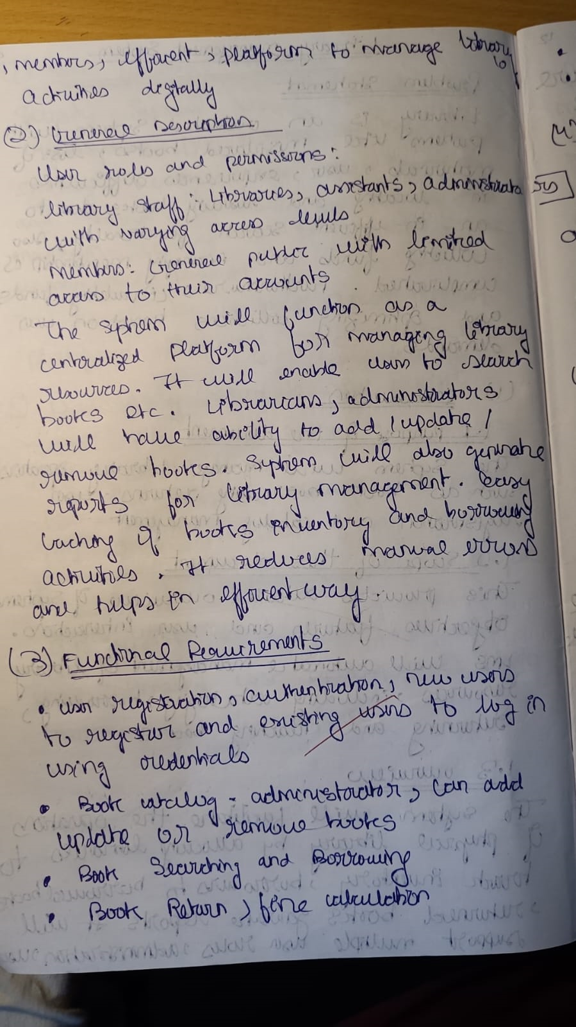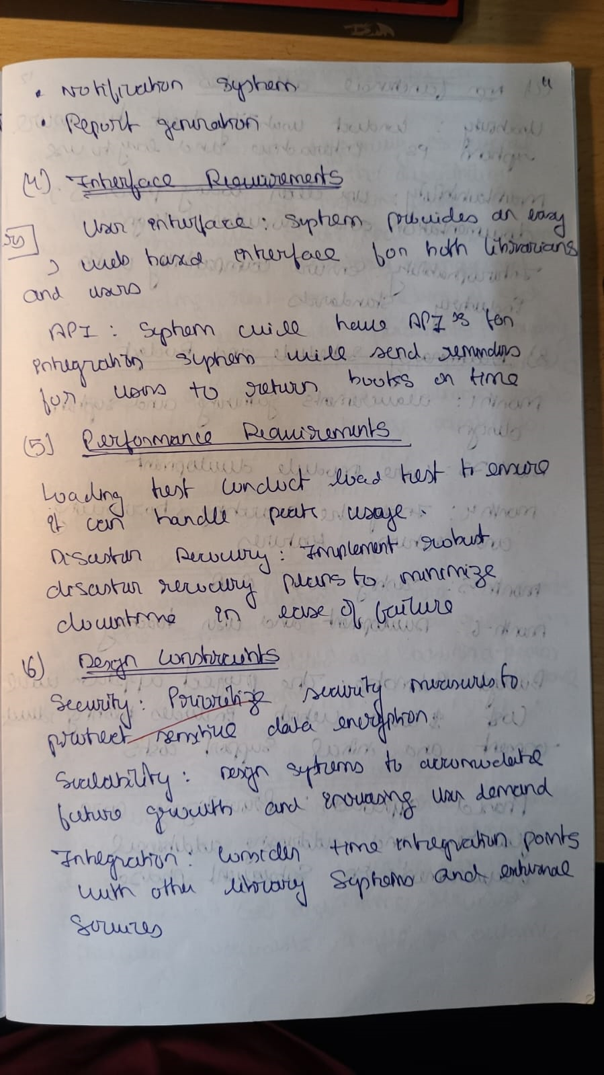

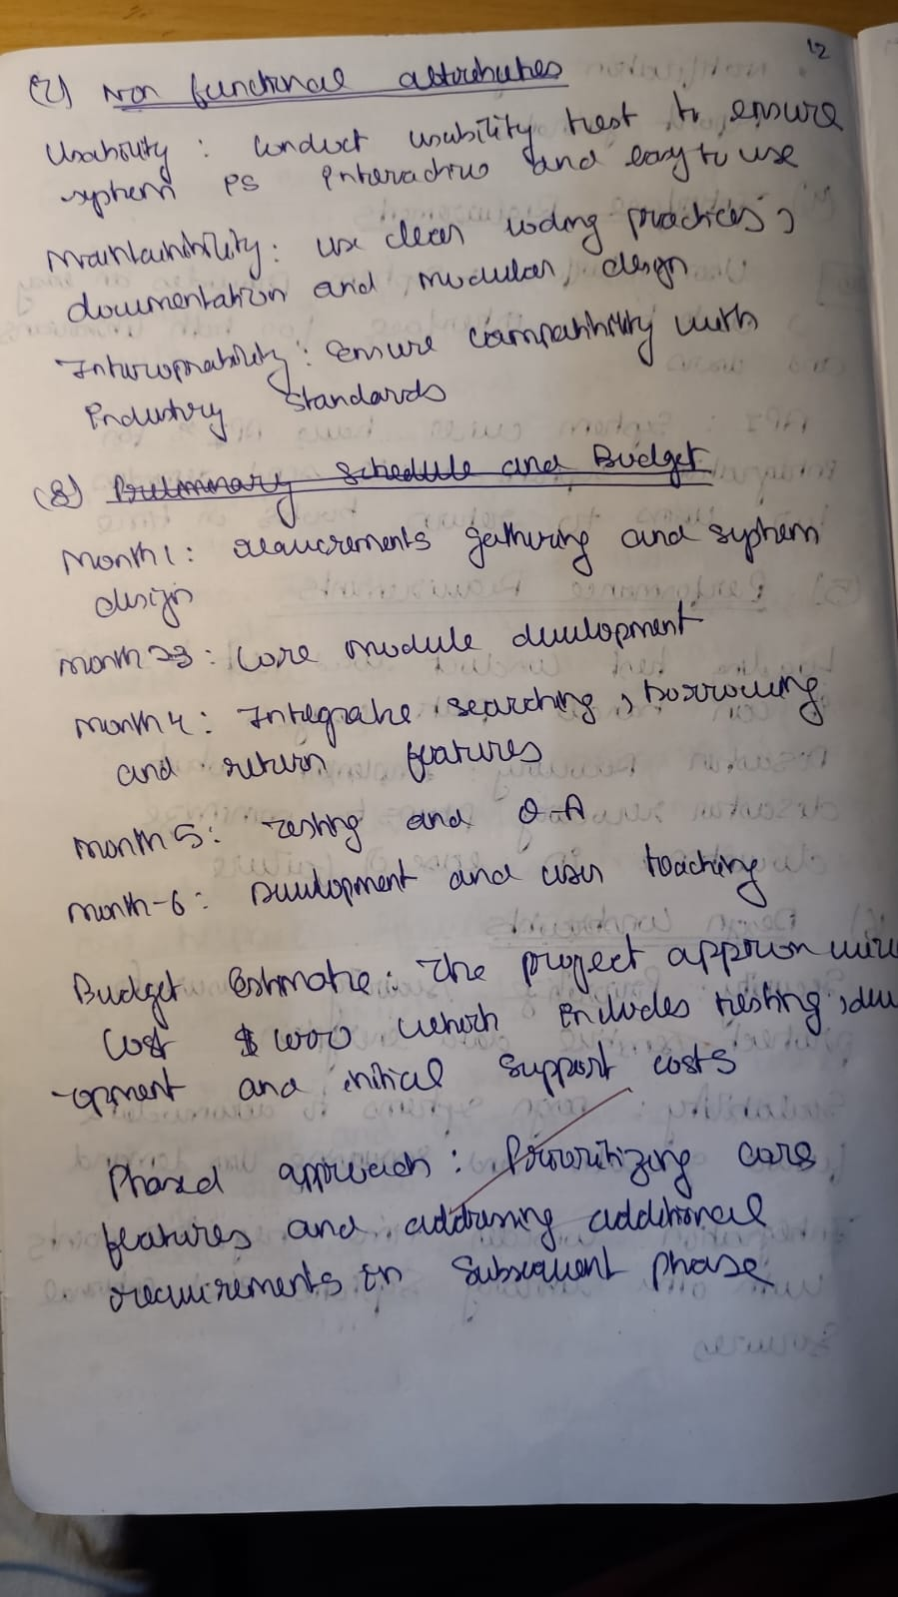

**Stock Maintenance System**

**Problem Statement:**

Businesses often struggle to maintain accurate inventory levels, leading to stock shortages or excess stock, which affects operational efficiency. Without a proper system to track stock levels and generate alerts, companies can suffer from lost sales or overstocking costs. A Stock Maintenance System is required to automate stock tracking, alert staff about low stock levels, and generate reports for effective inventory management.

**1. Introduction:**

* **1.1 Purpose:**  
  This SRS defines a Stock Maintenance System (SMS) to manage business inventory.
* **1.2 Scope:**  
  The system will track stock levels, manage inventory, and generate low stock alerts. Development will take 3 months with a budget of $25,000.
* **1.3 Overview:**  
  SMS will help businesses maintain accurate stock records and automate the replenishment process.

**2. General Description:**  
The system will be used by warehouse and inventory managers to monitor stock levels.

**3. Functional Requirements:**

* Inventory tracking (incoming, outgoing).
* Low stock alerts.

**4. Interface Requirements:**  
GUI for warehouse staff, with integration to supplier management systems.

**5. Performance Requirements:**  
Inventory updates must occur within 1 second of stock change.

**6. Design Constraints:**  
The system must be compatible with existing enterprise resource planning (ERP) tools.

**7. Non-Functional Attributes:**

* Reliable and scalable.
* Real-time data integrity.

**8. Preliminary Schedule and Budget:**  
Development will take 3 months with a budget of $25,000.

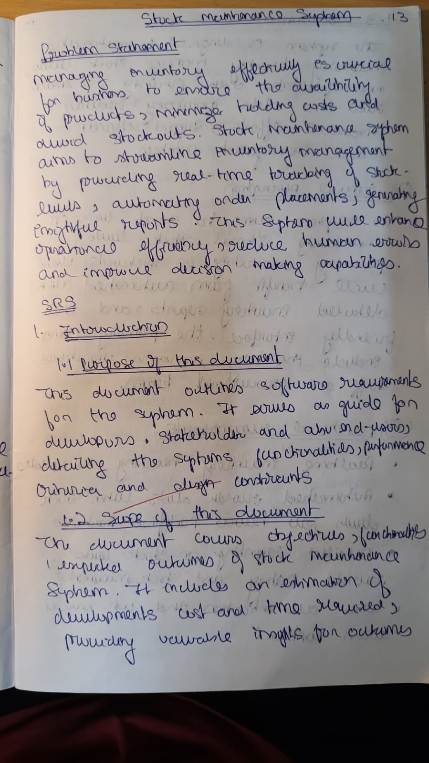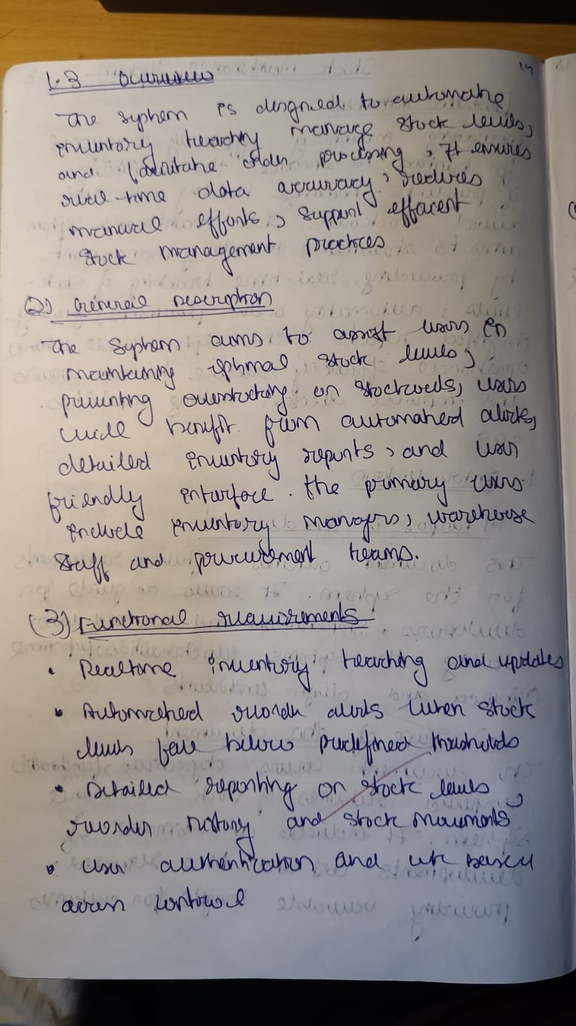

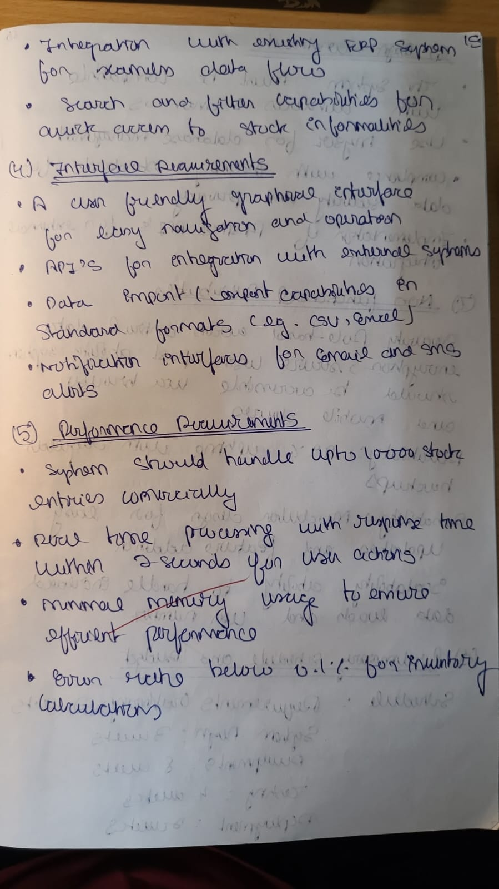

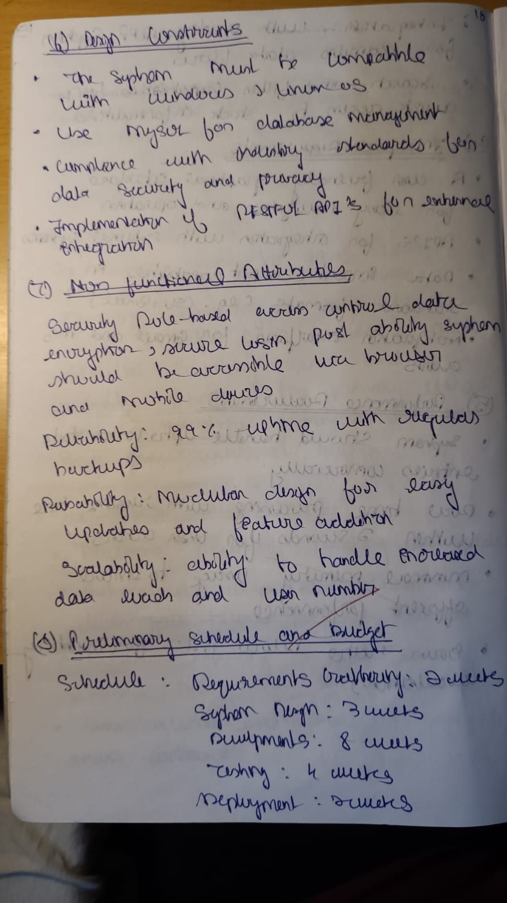

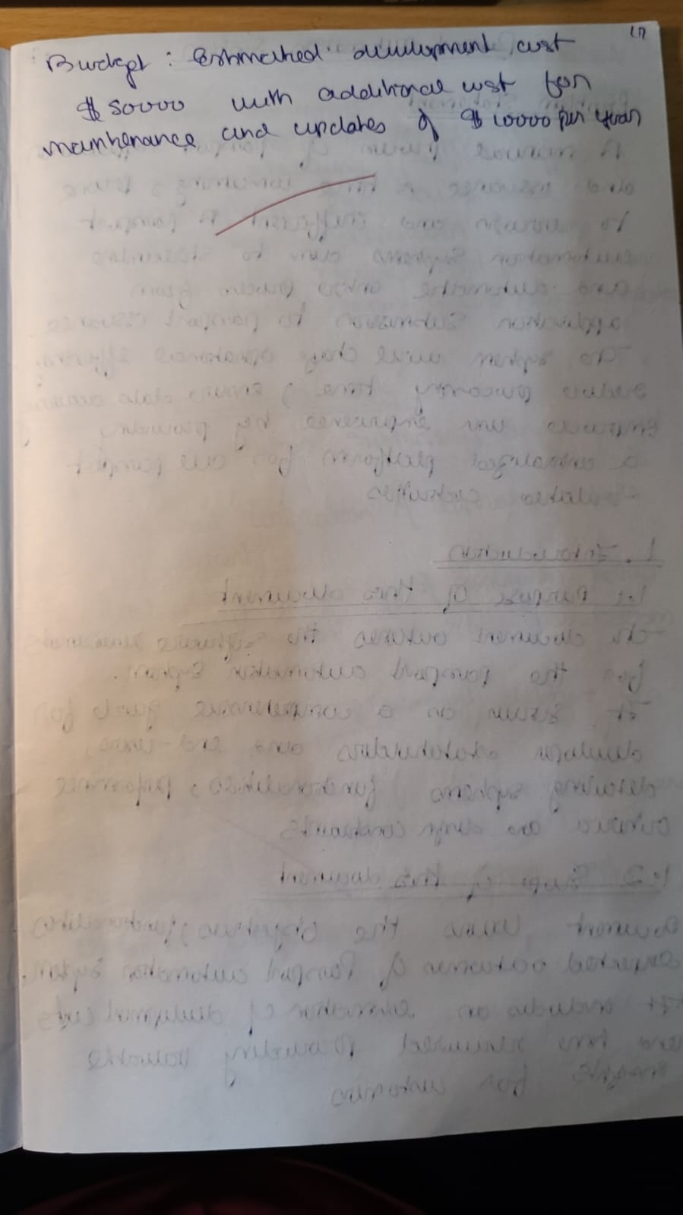

**Passport Automation System**

**Problem Statement:**

The manual passport application process is often slow, cumbersome, and prone to delays, causing frustration for applicants. Long waiting times for document verification and application status updates lead to inefficiency in passport issuance. There is a need for a Passport Automation System that simplifies the application process, automates status tracking, and integrates with document verification to ensure timely passport issuance.

**1. Introduction:**

* **1.1 Purpose:**  
  The document outlines the SRS for Passport Automation System (PAS), automating the passport application process.
* **1.2 Scope:**  
  PAS will handle passport applications, document verification, and appointment scheduling. Development will take 6 months with a budget of $50,000.
* **1.3 Overview:**  
  The system will streamline passport applications, from submission to approval and issuance.

**2. General Description:**  
The system will be used by applicants and passport authorities to manage applications.

**3. Functional Requirements:**

* Applicant registration and document submission.
* Status tracking and passport issuance.

**4. Interface Requirements:**  
Integration with government databases for verification.

**5. Performance Requirements:**  
The system must process application statuses within 2 seconds.

**6. Design Constraints:**  
The system must adhere to government regulations for passport issuance.

**7. Non-Functional Attributes:**

* Secure and reliable.
* Scalable for high user loads.

**8. Preliminary Schedule and Budget:**  
Development will take 6 months with a budget of $50,000.

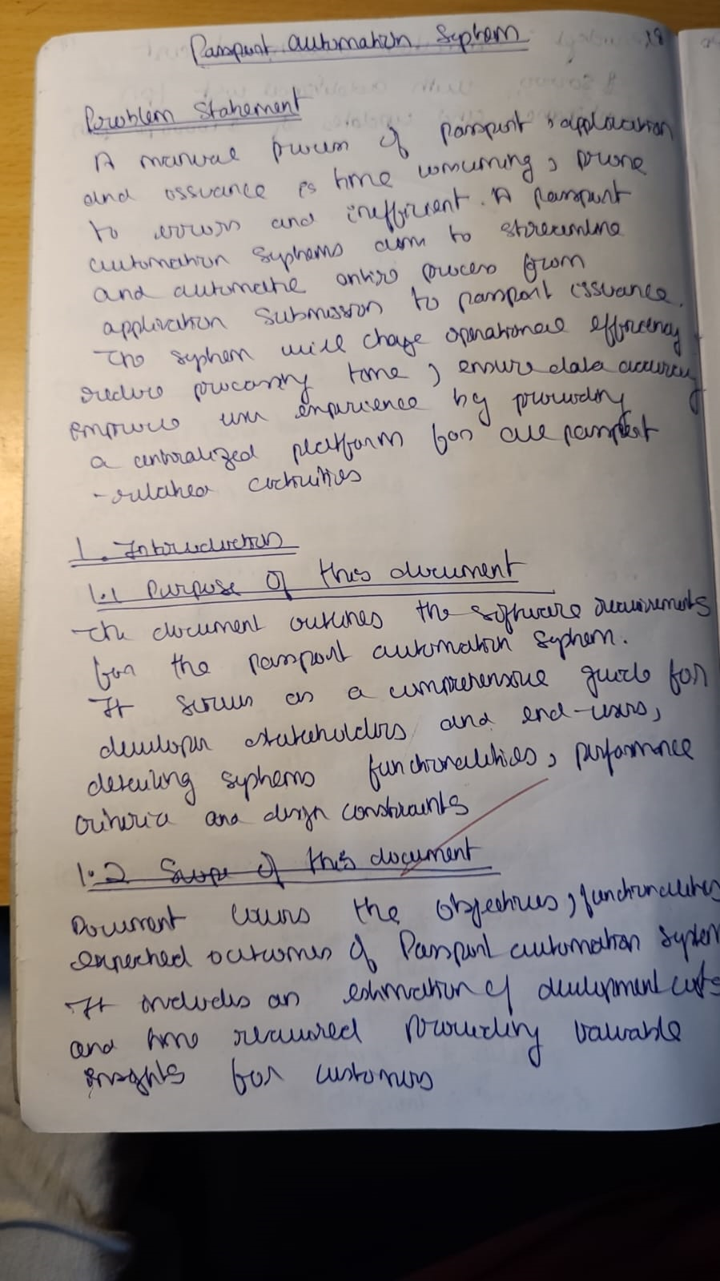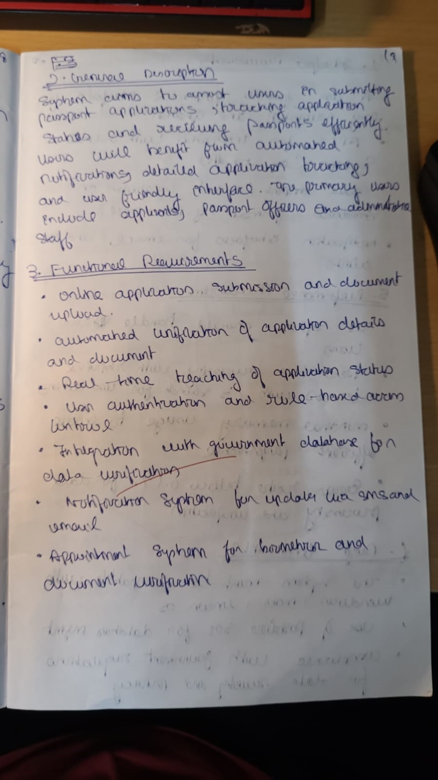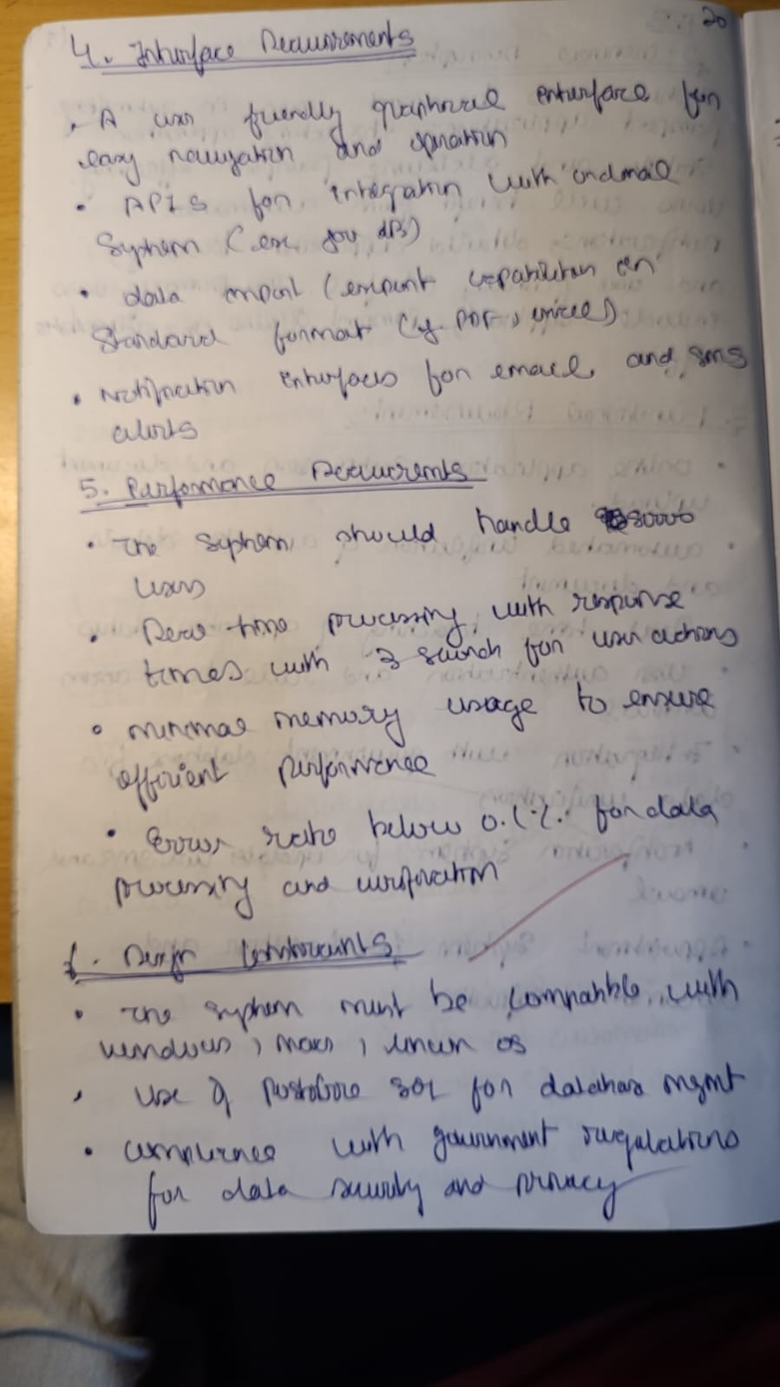

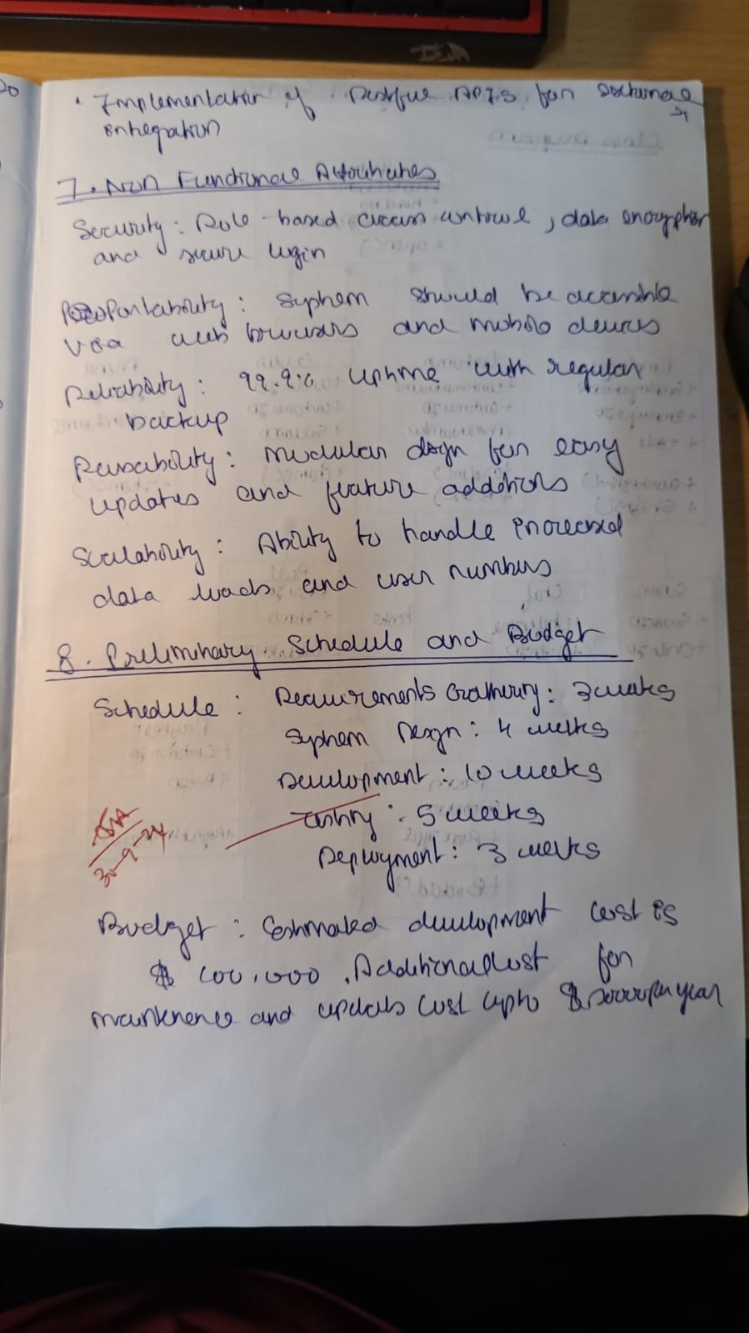

1. **CLASS MODELLING**

**Hotel Management System**

**Classes:**

* **Hotel**: Represents the overall hotel, with attributes like name, location, etc.
* **Room**: Represents individual rooms in the hotel with attributes like room number, type, price, and availability.
* **Guest**: Represents customers staying at the hotel, with attributes like name, contact information, and booking details.
* **Booking**: Represents the booking details, containing the check-in date, check-out date, and guest information.
* **Service**: Represents services provided by the hotel (e.g., room service), with attributes like service type and cost.
* **Invoice**: Represents billing details, with attributes like total amount, payment method, etc.

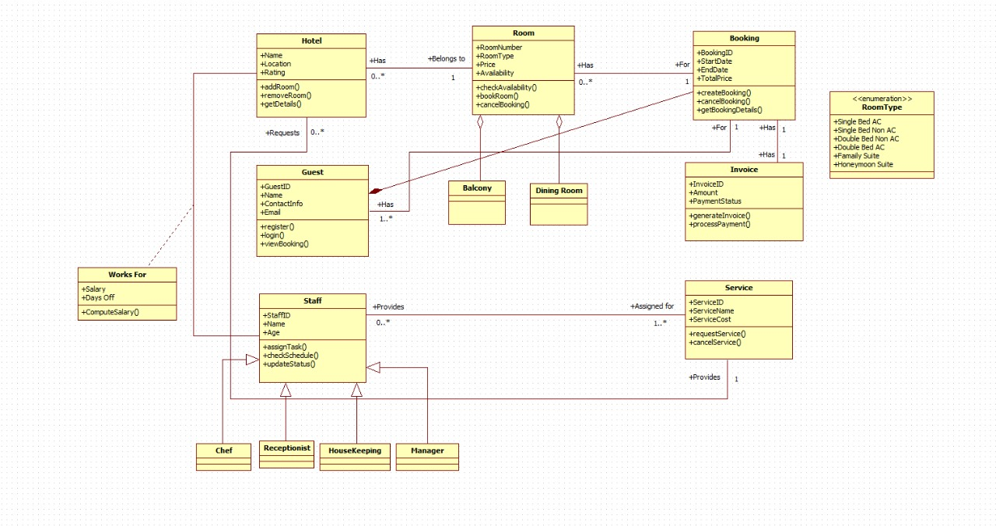

**Figure 2.1 - HMS Class Diagram**

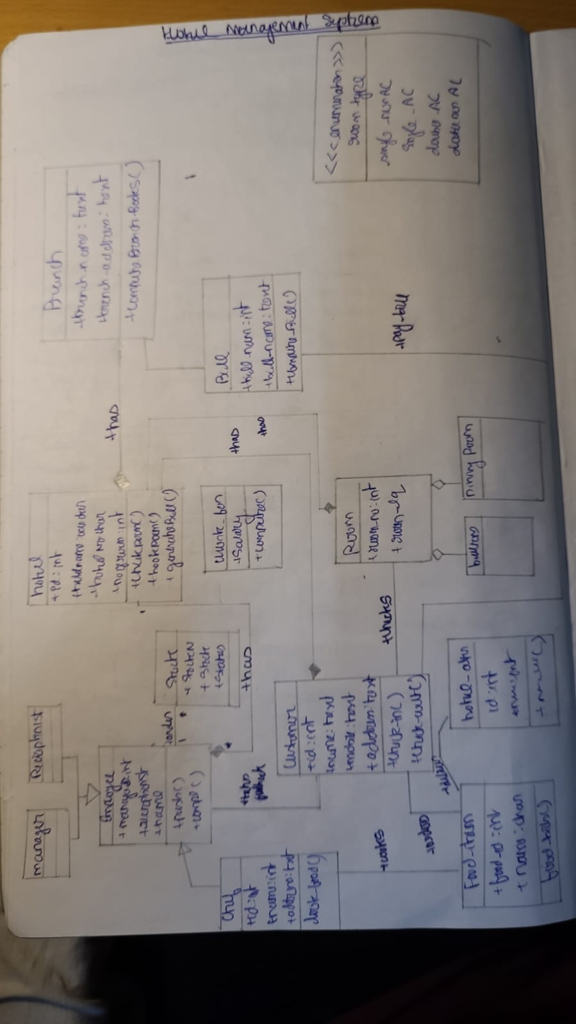

**Credit Card Processing System**

**Classes:**

* **Customer**: Represents the cardholder, with attributes like name, card number, and billing address.
* **Transaction**: Represents individual credit card transactions, with attributes like transaction ID, amount, date, and status.
* **Merchant**: Represents a business or vendor accepting payments, with attributes like merchant ID, name, and location.
* **Bank**: Represents the bank issuing the credit card, with attributes like bank name and account details.
* **Payment Gateway**: Represents the system responsible for processing payments, with attributes like gateway ID and API details.

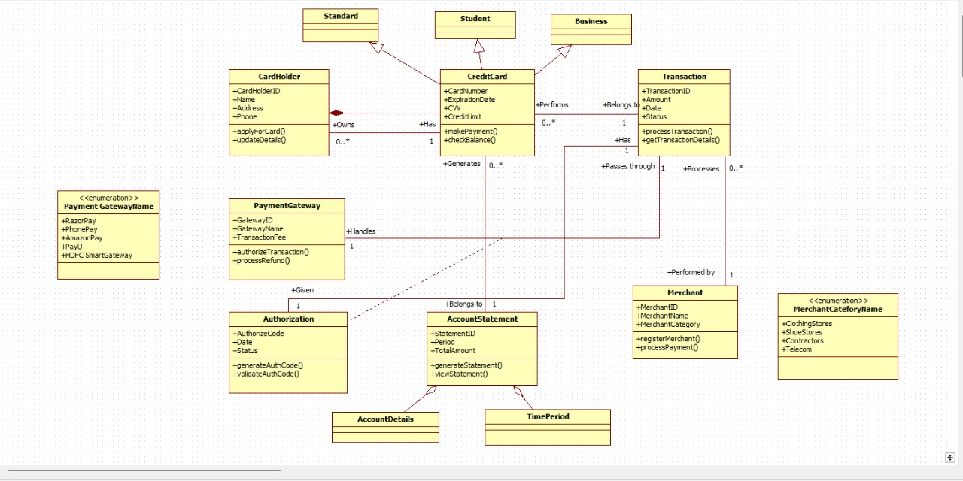

**Figure 2.2 – CCPS Class Diagram**

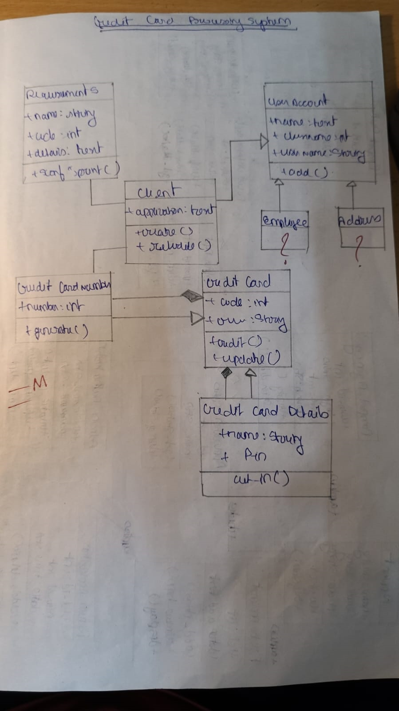

**Library Management System**

**Classes:**

* **Library**: Represents the overall library system, with attributes like name, location, and catalog.
* **Book**: Represents individual books in the library, with attributes like title, author, ISBN, and availability.
* **Member**: Represents a library member, with attributes like name, membership ID, and contact details.
* **Loan**: Represents the loan of a book, with attributes like loan ID, issue date, and due date.
* **Fine**: Represents a fine for overdue books, with attributes like fine amount and payment status.

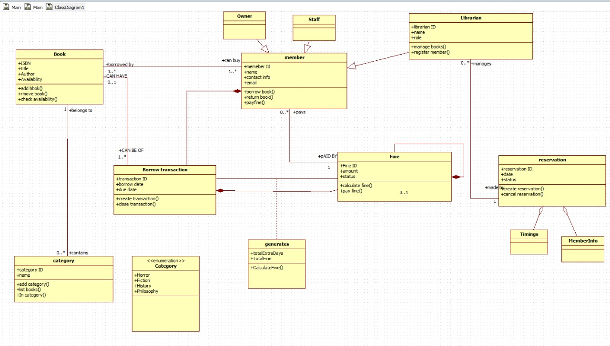

**Figure 2.3 – LMS Class Diagram**

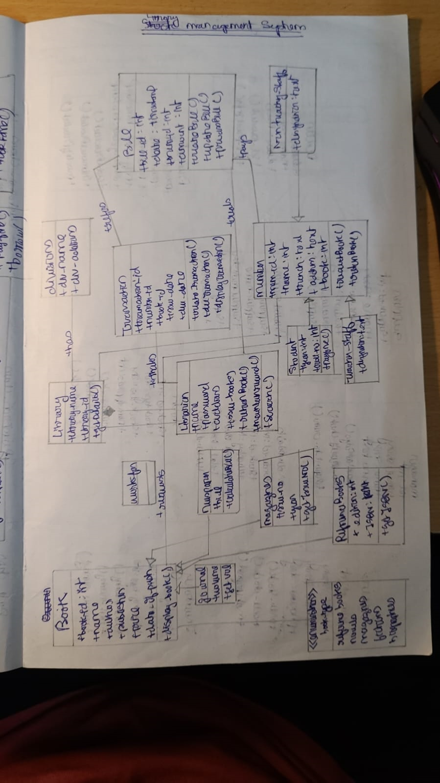

**Stock Maintenance System**

**Classes:**

* **Warehouse**: Represents the storage location for stock items, with attributes like warehouse ID and location.
* **Item**: Represents individual stock items, with attributes like item ID, name, quantity, and price.
* **Supplier**: Represents the entity supplying items, with attributes like supplier name and contact details.
* **Order**: Represents orders placed for restocking, with attributes like order ID, date, and items ordered.
* **Inventory**: Represents the overall stock, with attributes like total stock levels and low stock alerts.

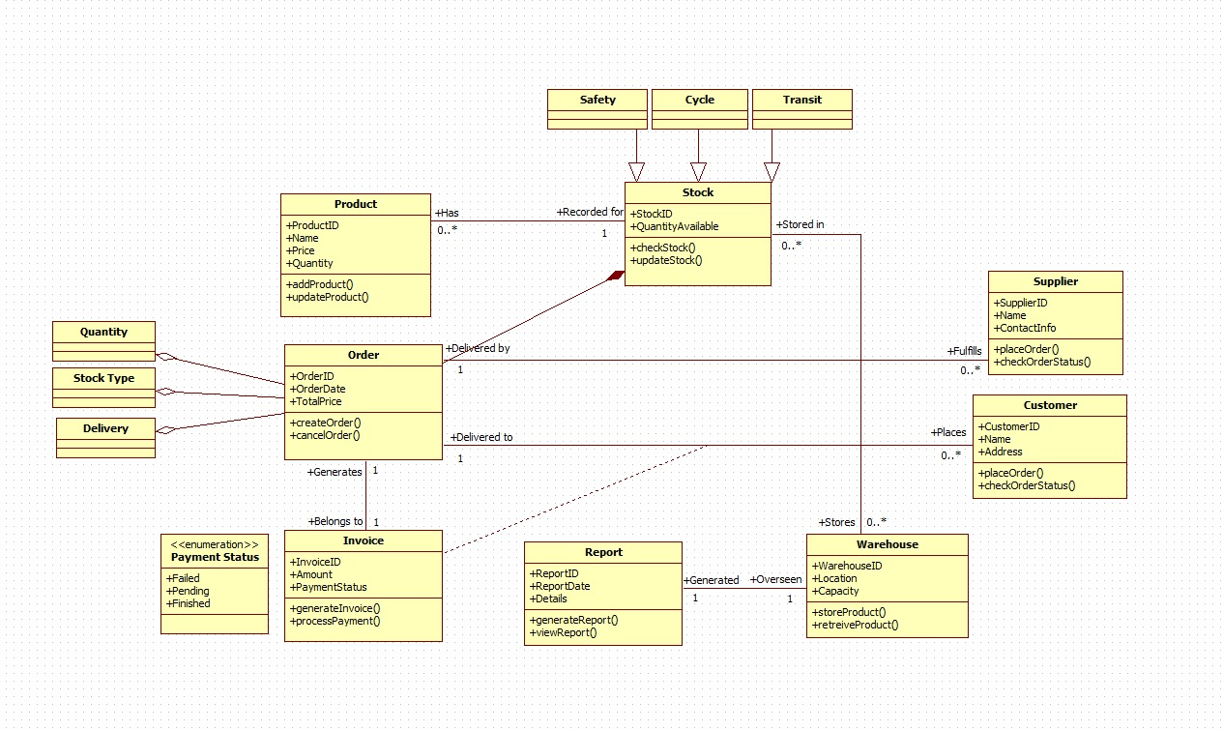

**Figure 2.4 – SMS Class Diagram**

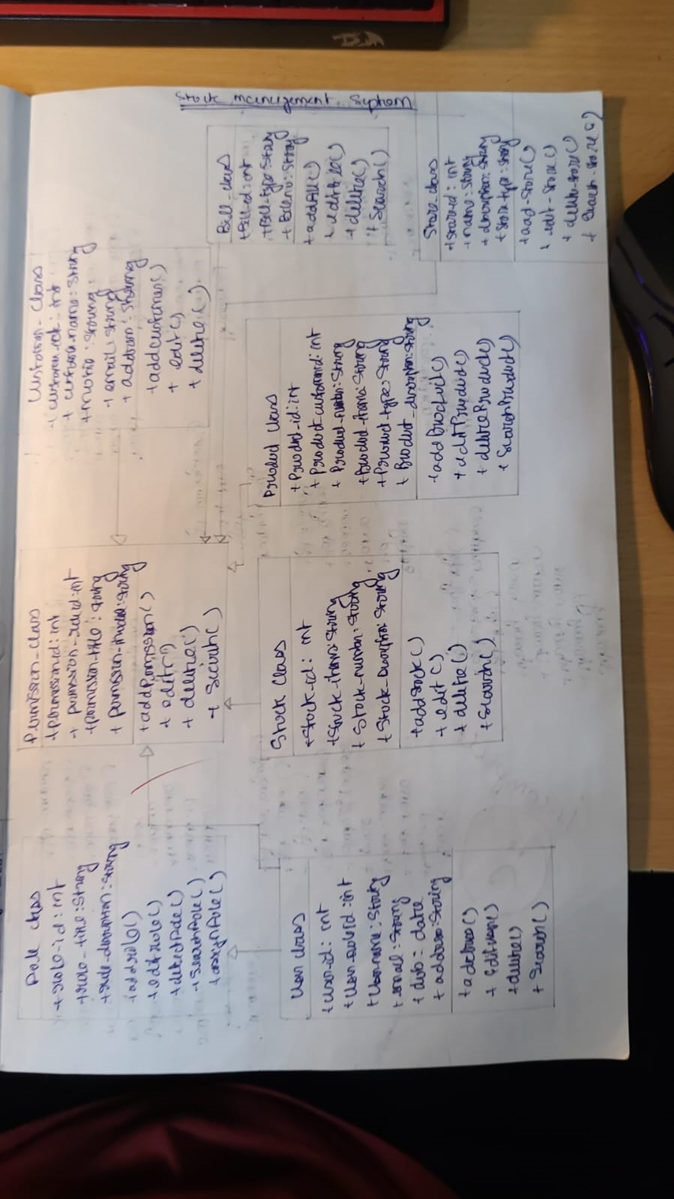

**Passport Automation System**

**Classes:**

* **Applicant**: Represents an individual applying for a passport, with attributes like name, address, and ID proof.
* **Application**: Represents the passport application, with attributes like application ID, status, and submission date.
* **Appointment**: Represents an appointment for document verification, with attributes like appointment ID, date, and time.
* **Document**: Represents documents submitted by the applicant, with attributes like document ID, type, and status.
* **Passport**: Represents the issued passport, with attributes like passport number, issue date, and expiration date.

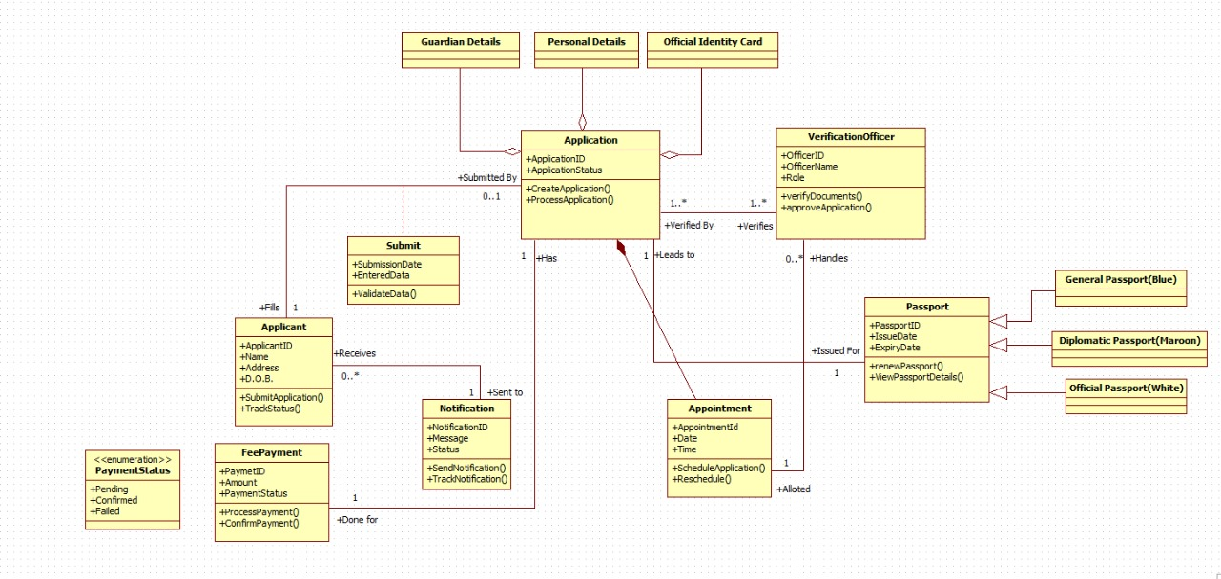

**Figure 2.5 - PAS Class Diagram**

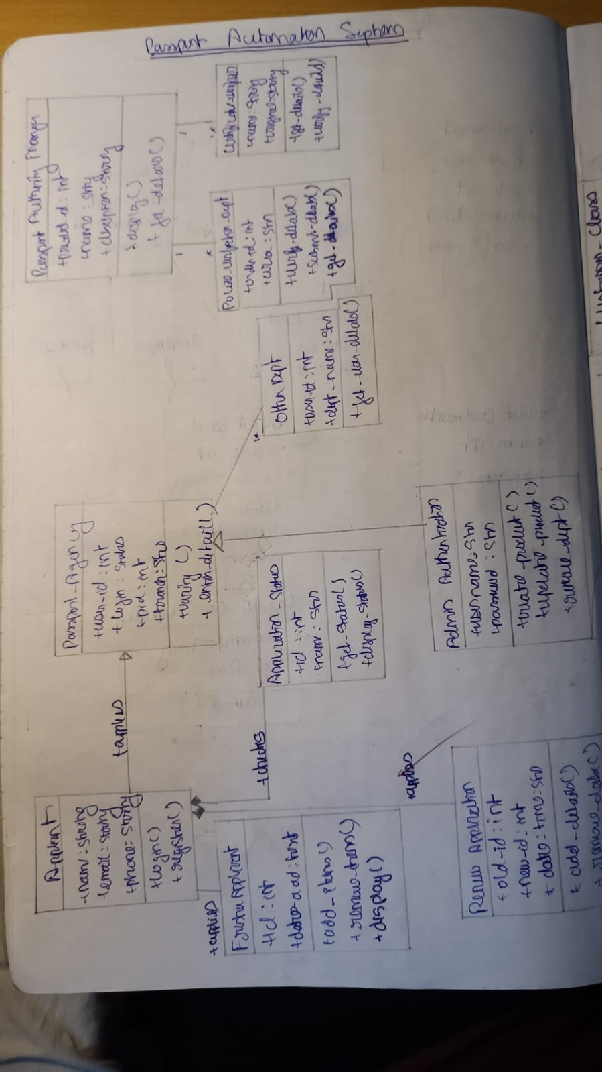

1. **STATE MODELLING**

**Hotel Management System**

**States:**

* **Initial**: Start of booking process.
* **Room Selected**: Room selection completed.
* **Guest Details Entered**: Guest details are entered.
* **Payment Processed**: Payment is completed.
* **Booking Confirmed**: Booking is confirmed.
* **Checked In**: Guest has checked into the room.
* **Checked Out**: Guest has checked out, ending the booking process.

**Transitions:**

* **Select Room**: Initial → Room Selected
* **Enter Guest Details**: Room Selected → Guest Details Entered
* **Process Payment**: Guest Details Entered → Payment Processed
* **Confirm Booking**: Payment Processed → Booking Confirmed
* **Check In**: Booking Confirmed → Checked In
* **Check Out**: Checked In → Checked Out

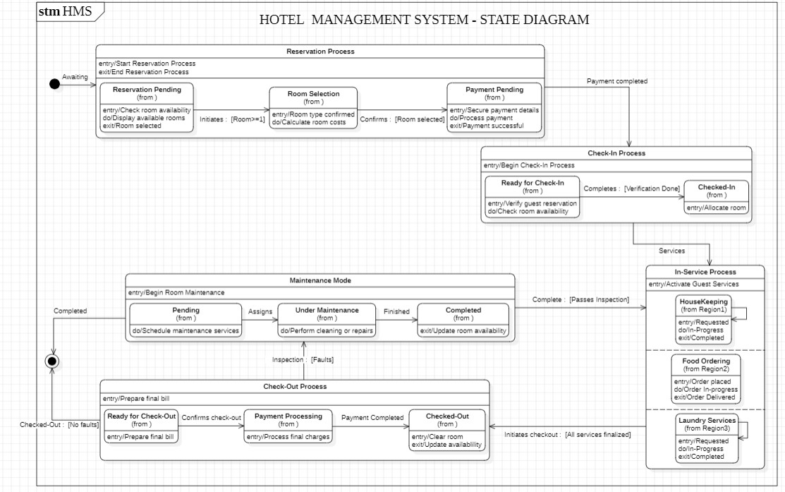

**Figure 3.1 – HMS State Diagram**

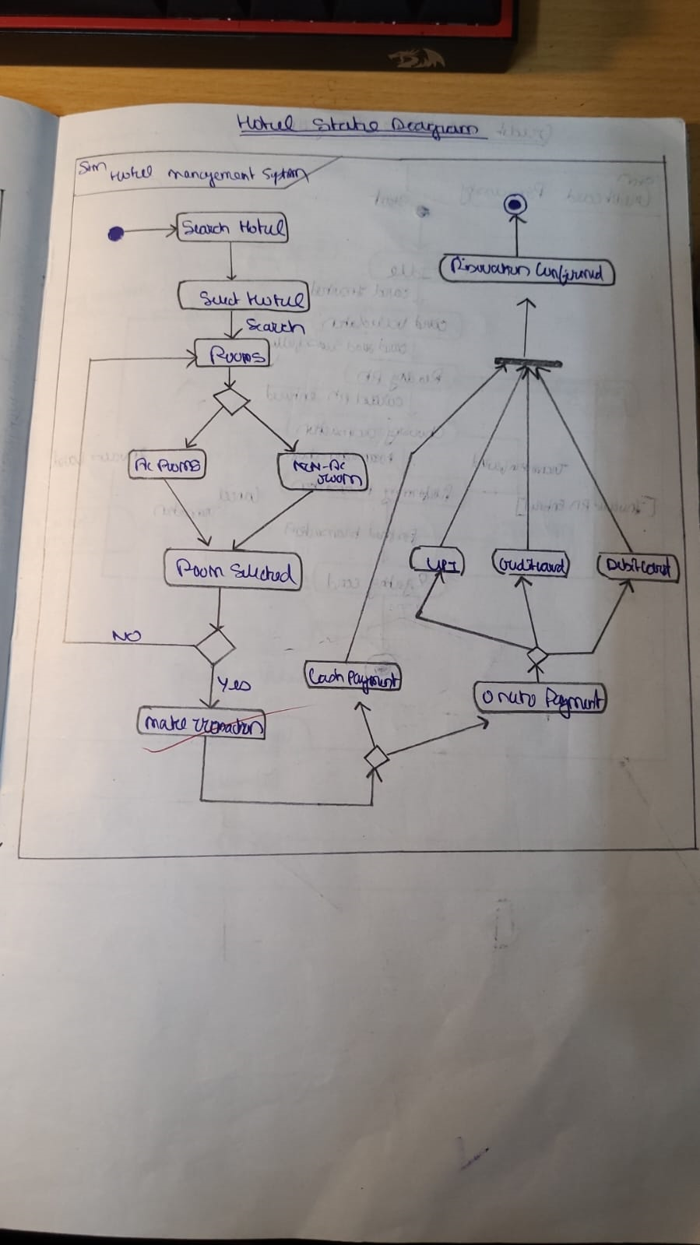

**Credit Card Processing System**

**States:**

* **Idle**: Ready to initiate a transaction.
* **Transaction Initiated**: Transaction has started.
* **Authorized**: Transaction authorized by the bank.
* **Processed**: Transaction completed.
* **Failed**: Transaction failed.
* **Refund Processed**: Refund issued (if applicable).

**Transitions:**

* **Initiate Transaction**: Idle → Transaction Initiated
* **Authorize**: Transaction Initiated → Authorized
* **Process Payment**: Authorized → Processed
* **Fail Transaction**: Transaction Initiated → Failed
* **Process Refund**: Processed → Refund Processed

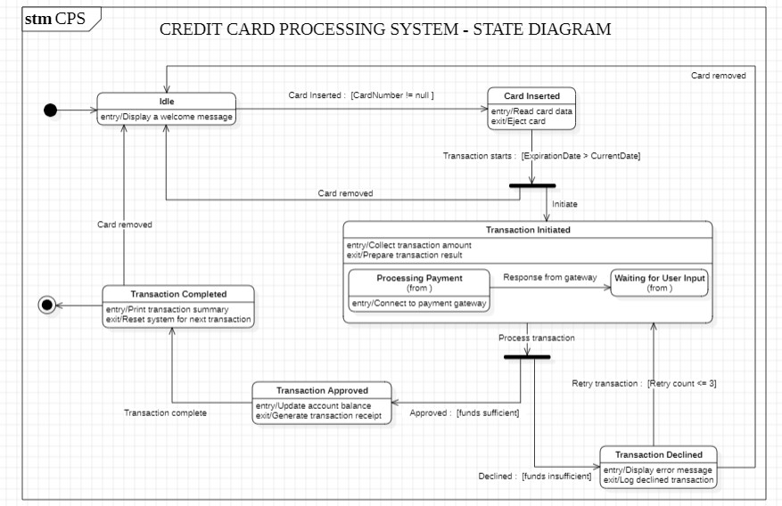

**Figure 3.2 – CCPS State Diagram**

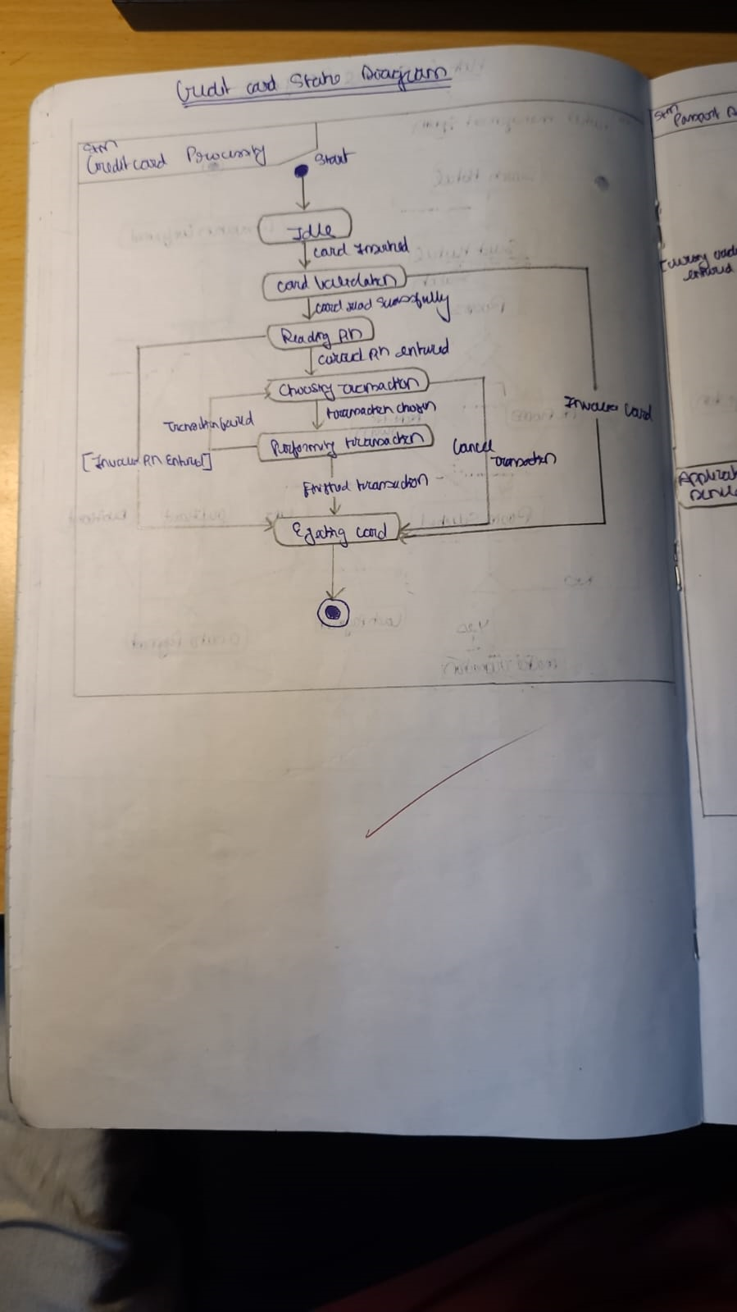

**Library Management System**

**States:**

* **Available**: Book is available in the library.
* **On Loan**: Book is borrowed by a member.
* **Overdue**: Book loan is overdue.
* **Returned**: Book is returned to the library.
* **Damaged**: Book is returned but marked as damaged.

**Transitions:**

* **Loan Book**: Available → On Loan
* **Mark Overdue**: On Loan → Overdue
* **Return Book**: On Loan → Returned
* **Return Damaged**: On Loan → Damaged
* **Return Overdue Book**: Overdue → Returned

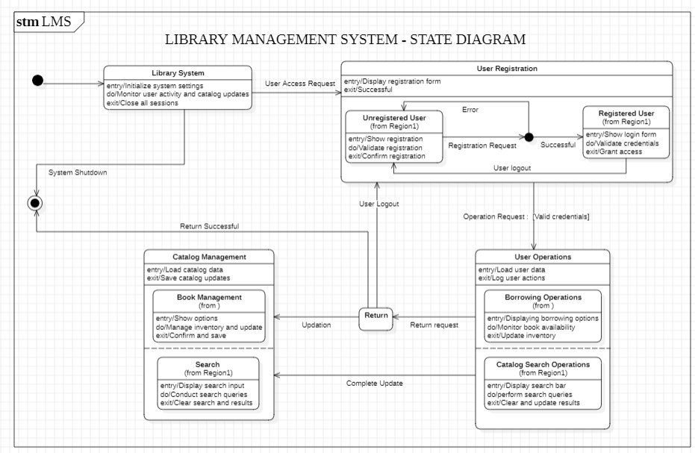

**Figure 3.3 – LMS State Diagram**

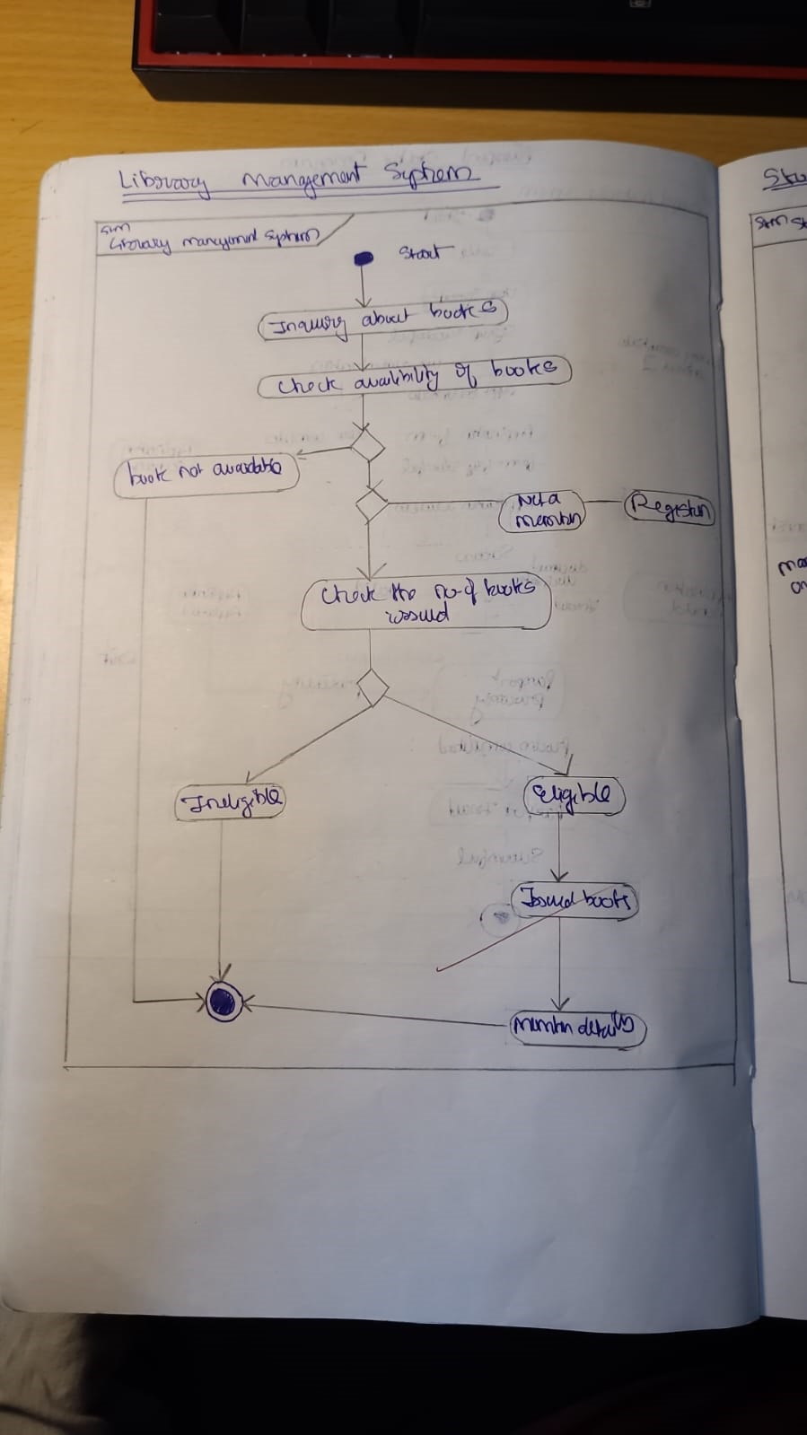

**Stock Maintenance System**

**States:**

* **In Stock**: Item is available in inventory.
* **Low Stock**: Stock level is low.
* **Out of Stock**: Item is out of stock.
* **Reordered**: Item has been reordered.
* **Restocked**: Item is restocked and available again.

**Transitions:**

* **Reduce Stock**: In Stock → Low Stock
* **Stock Exhausted**: Low Stock → Out of Stock
* **Place Order**: Out of Stock → Reordered
* **Receive Stock**: Reordered → Restocked
* **Replenish Stock**: Low Stock → In Stock

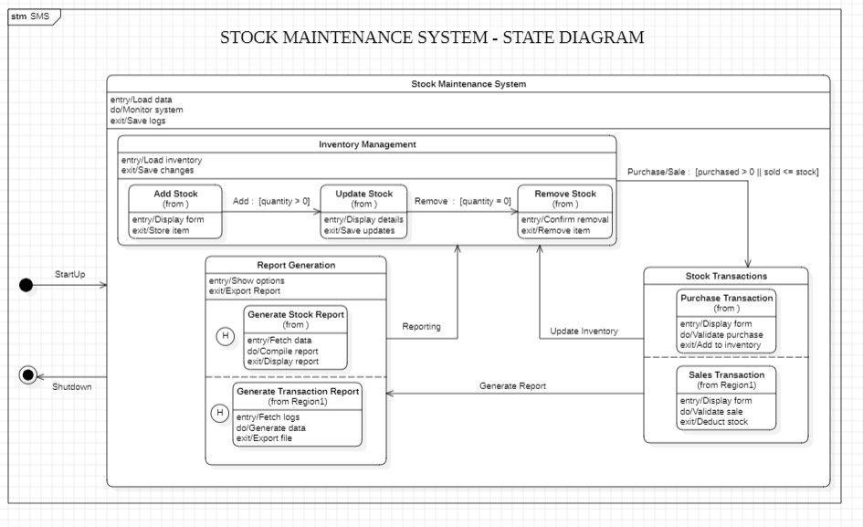

**Figure 3.4 – SMS State Diagram**

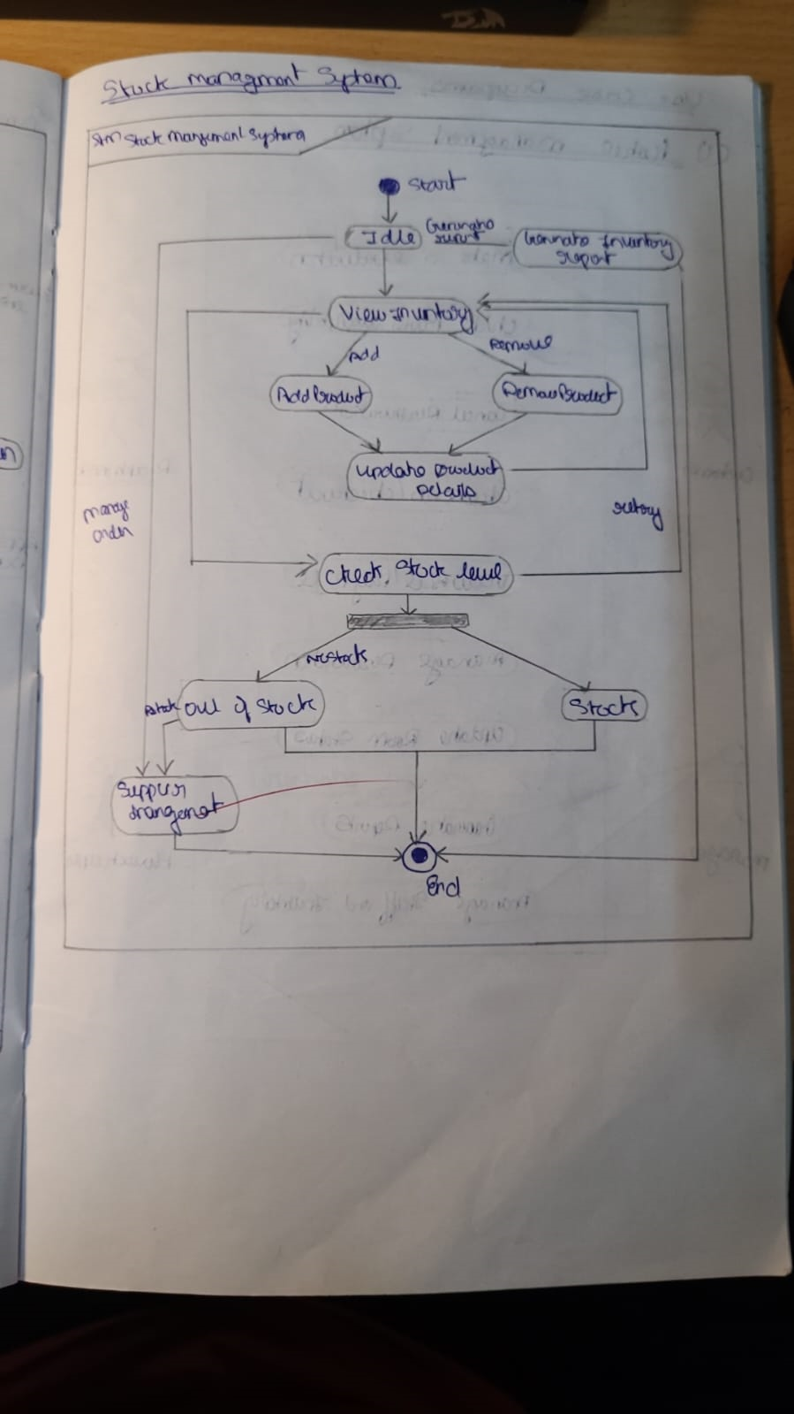

**Passport Automation System**

**States:**

* **Application Submitted**: Application submitted by applicant.
* **In Review**: Application is being reviewed.
* **Document Verification**: Documents are verified.
* **Approved**: Application is approved.
* **Rejected**: Application is rejected.
* **Passport Issued**: Passport is issued.

**Transitions:**

* **Submit Application**: Start → Application Submitted
* **Review Application**: Application Submitted → In Review
* **Verify Documents**: In Review → Document Verification
* **Approve Application**: Document Verification → Approved
* **Reject Application**: Document Verification → Rejected
* **Issue Passport**: Approved → Passport Issued

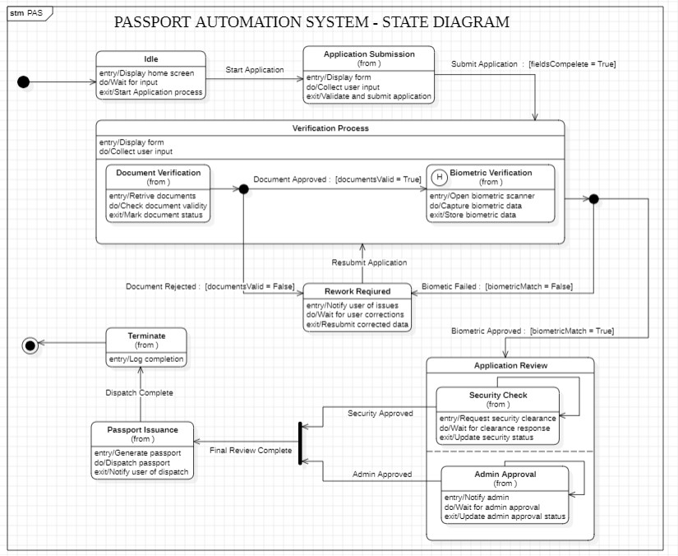

**Figure 3.5 – PAS State Diagram**

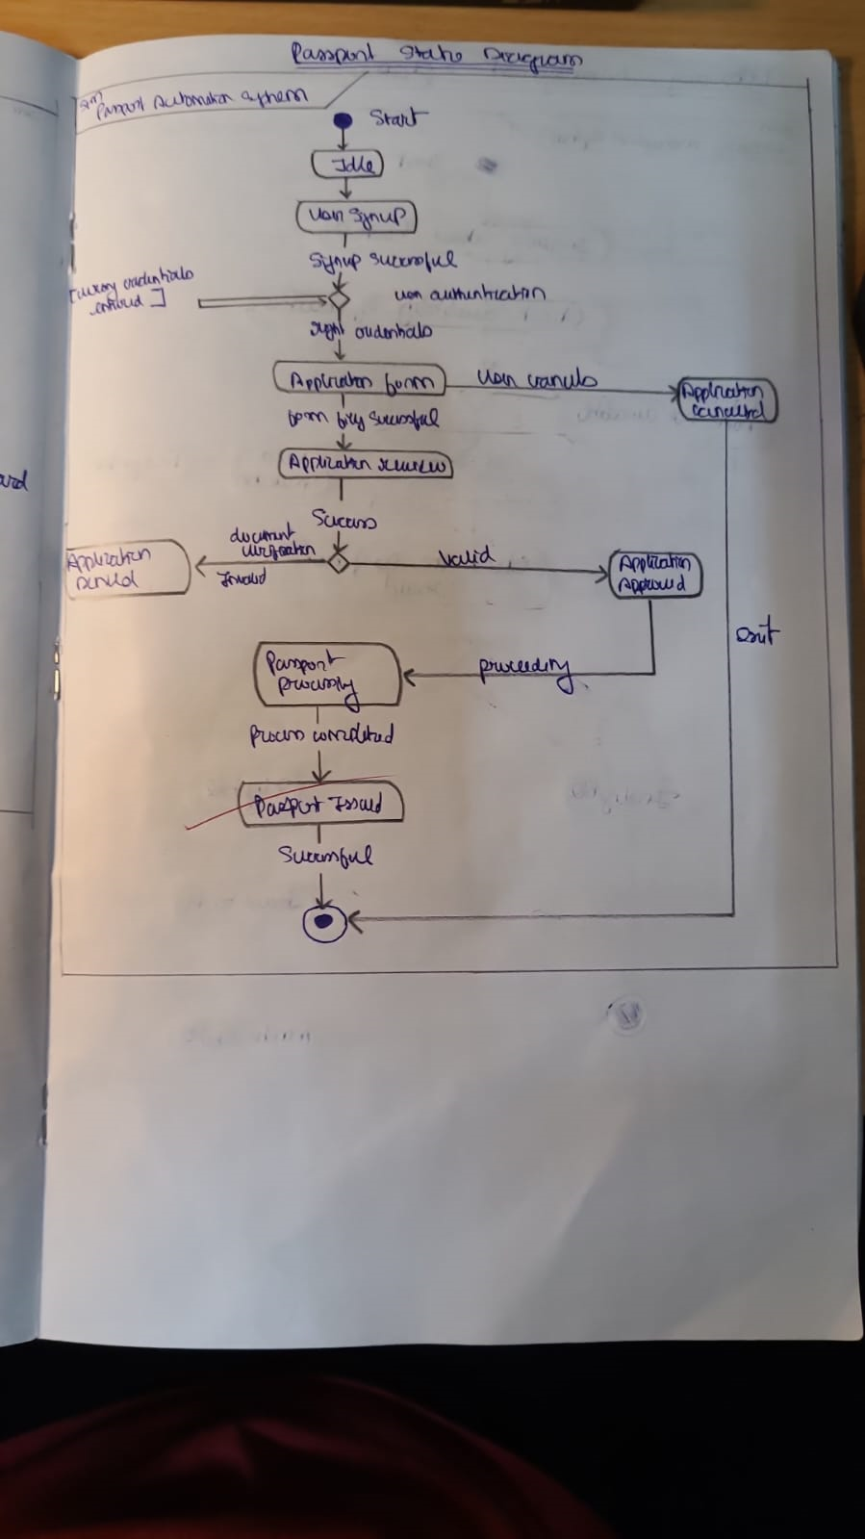

1. **INTERACTION MODELLING: USE CASE MODELS**

**Hotel Management System**

**Actors:**

* **Guest**: Interacts with the system to book rooms, avail services, and make payments.
* **Receptionist**: Manages guest details, room allocation, and service requests.
* **Housekeeping**: Handles room cleaning requests and status updates.

**Use Cases:**

* **Book Room**: Allows guests to reserve rooms.
* **Make Payment**: Handles payment processing for bookings and services.
* **Check-In**: Completes the check-in process for guests.
* **Check-Out**: Handles guest departures and generates invoices.
* **Request Room Service**: Enables guests to request additional services.

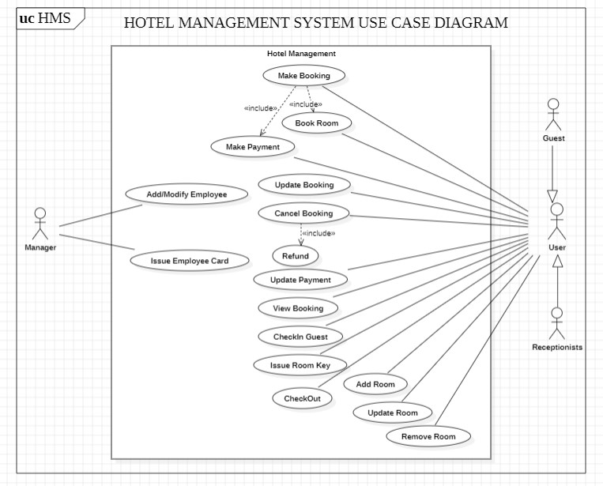

**Figure 4.1 – HMS Use Case Diagram**

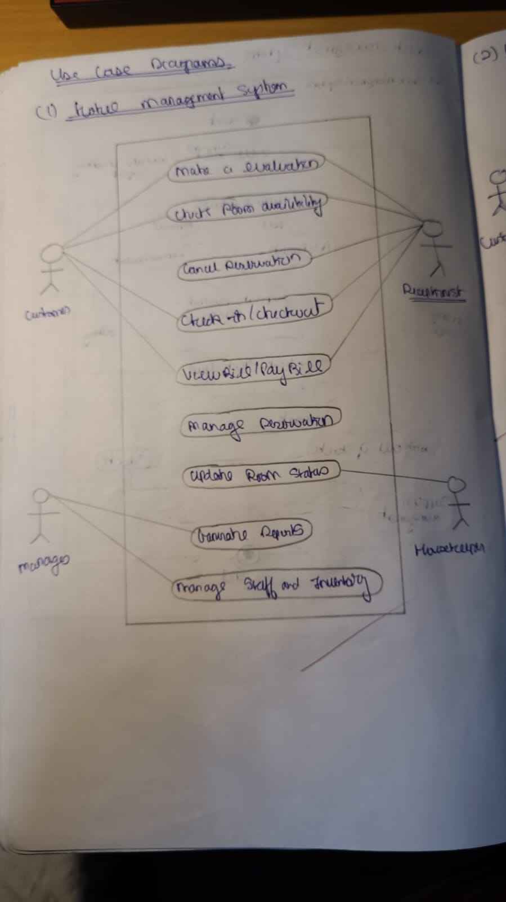

**Credit Card Processing System**

**Actors:**

* **Cardholder**: Uses the credit card for transactions.
* **Merchant**: Accepts credit card payments.
* **Bank**: Processes and authorizes transactions.
* **Payment Gateway**: Facilitates secure communication between systems.

**Use Cases:**

* **Initiate Transaction**: Begins the transaction process.
* **Authorize Payment**: Verifies the transaction with the issuing bank.
* **Process Payment**: Completes the payment process.
* **Issue Refund**: Handles refunds for failed or disputed transactions.

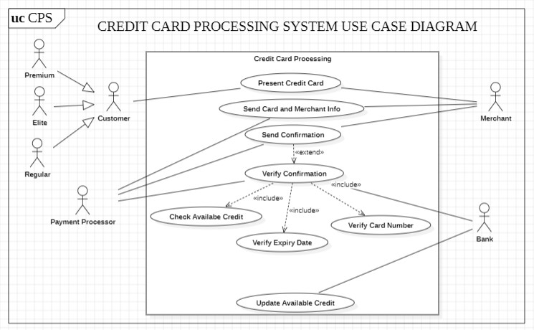

**Figure 4.2 – CCPS Use Case Diagram**

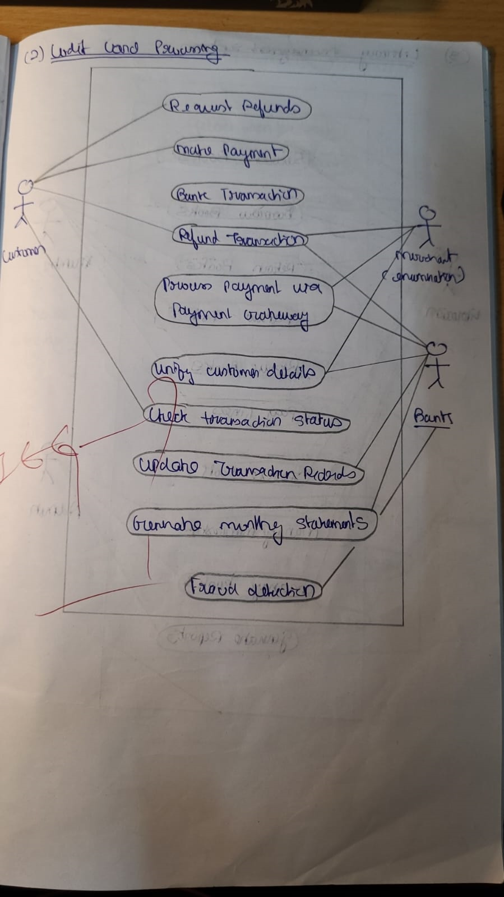

**Library Management System**

**Actors:**

* **Member**: Borrows, returns, and renews books.
* **Librarian**: Manages inventory, loans, and member registrations.

**Use Cases:**

* **Borrow Book**: Allows members to borrow books from the library.
* **Return Book**: Handles the return of borrowed books.
* **Renew Book**: Extends the loan period for books.
* **Add New Book**: Enables librarians to update the catalog.
* **Pay Fine**: Handles overdue fine payments.

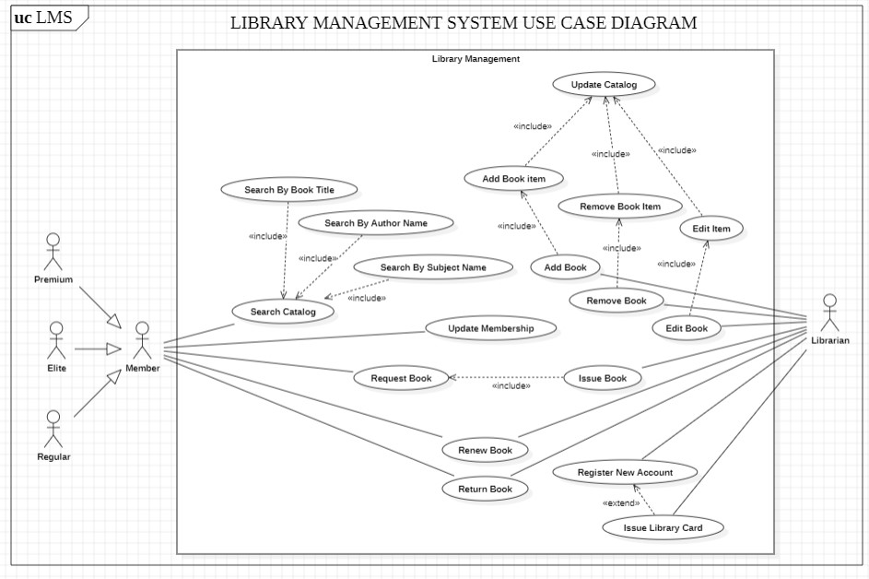

**Figure 4.3 – LMS Use Case Diagram**

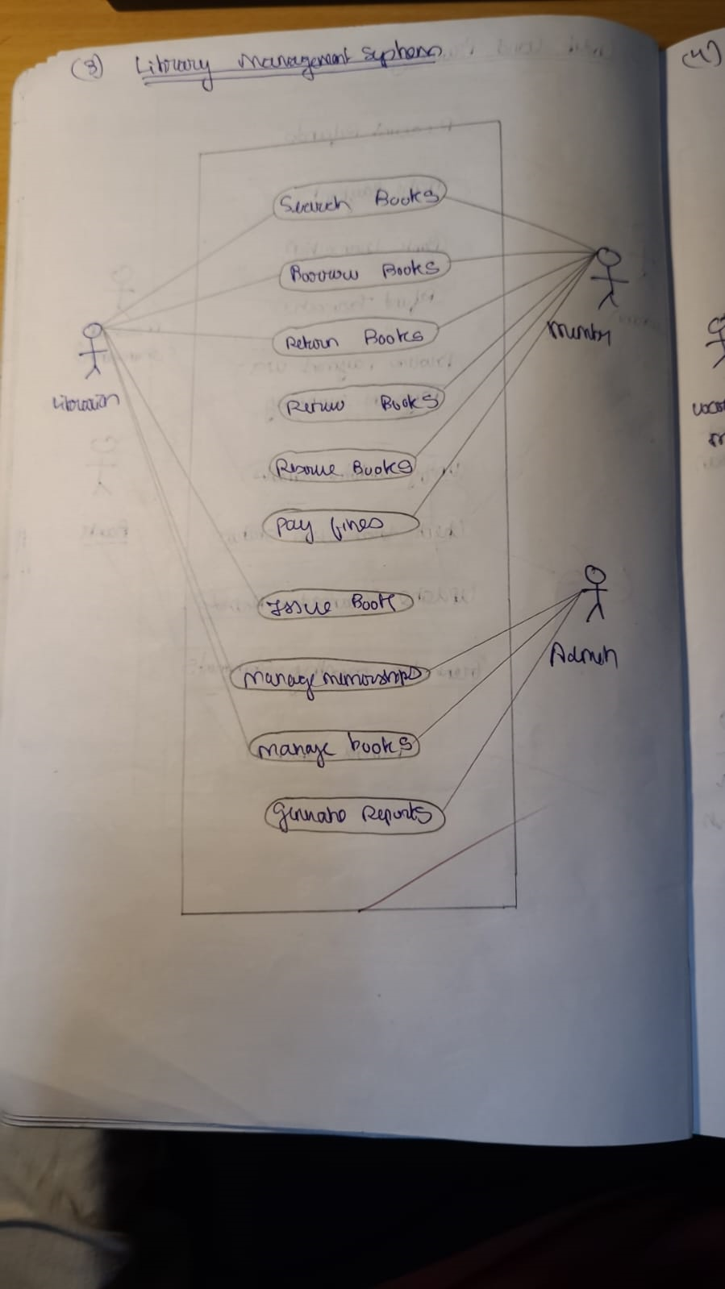

**Stock Maintenance System**

**Actors:**

* **Warehouse Manager**: Tracks inventory and places orders.
* **Supplier**: Supplies items to the warehouse.
* **System**: Monitors stock levels and triggers alerts.

**Use Cases:**

* **Monitor Stock**: Tracks current inventory levels.
* **Place Order**: Initiates the process of replenishing stock.
* **Receive Stock**: Updates inventory after new stock arrives.
* **Generate Low Stock Alert**: Notifies the manager when inventory is low.

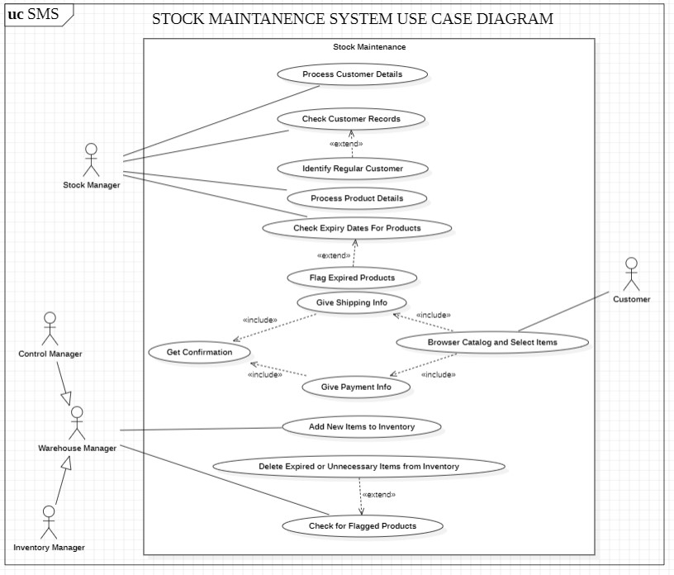

**Figure 4.4 – SMS Use Case Diagram**

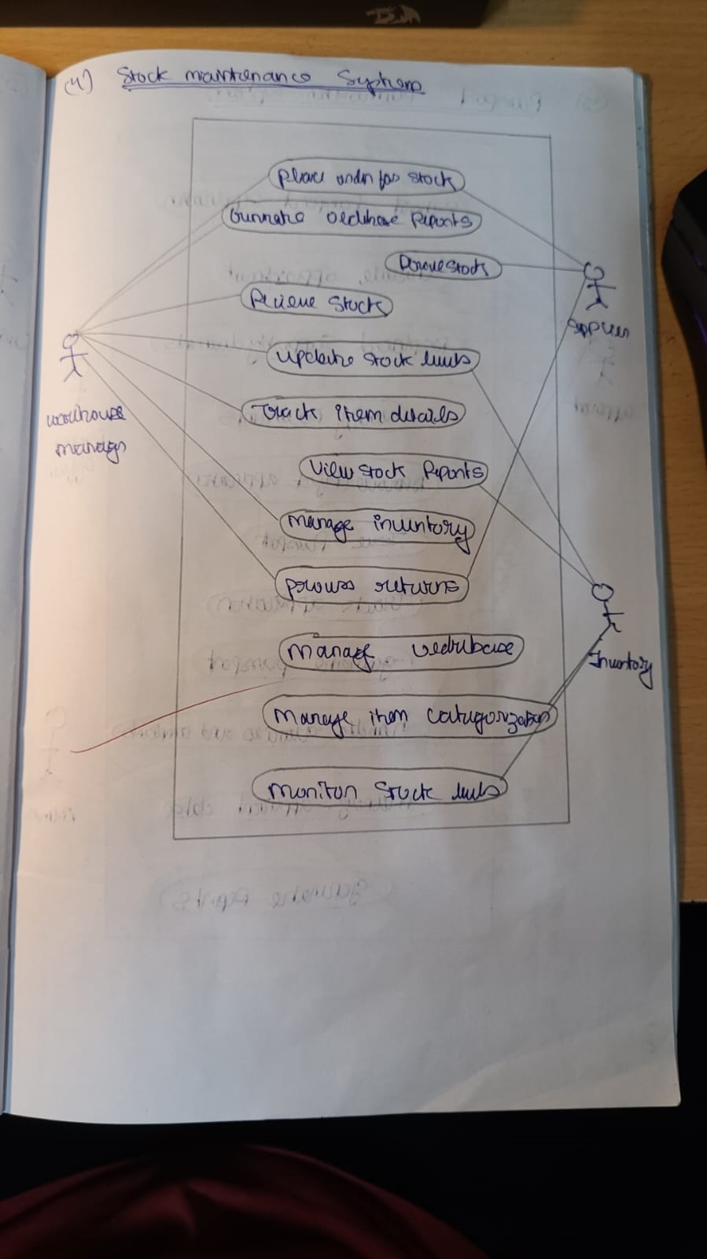

**Passport Automation System**

**Actors:**

* **Applicant**: Submits applications and schedules appointments.
* **Officer**: Reviews applications and verifies documents.
* **System**: Automates notifications and application tracking.

**Use Cases:**

* **Submit Application**: Allows applicants to apply for passports.
* **Schedule Appointment**: Enables applicants to book verification appointments.
* **Verify Documents**: Officers review and validate submitted documents.
* **Approve Application**: Approves applications after review.
* **Issue Passport**: Completes the application process by generating passports.

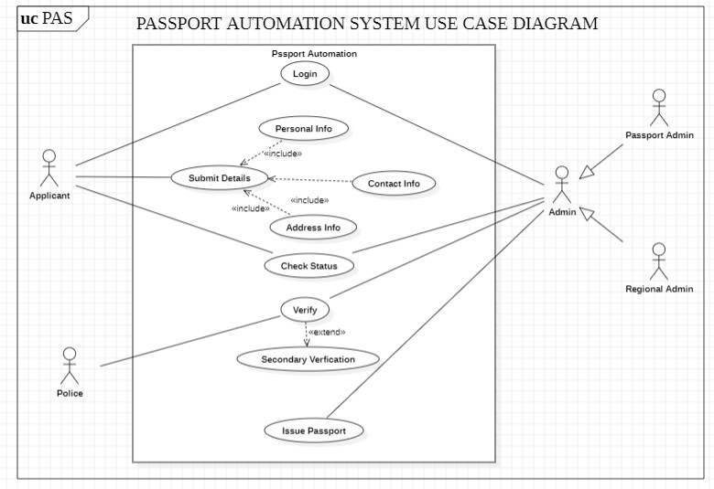

**Figure 4.5 – PAS Use Case Diagram**

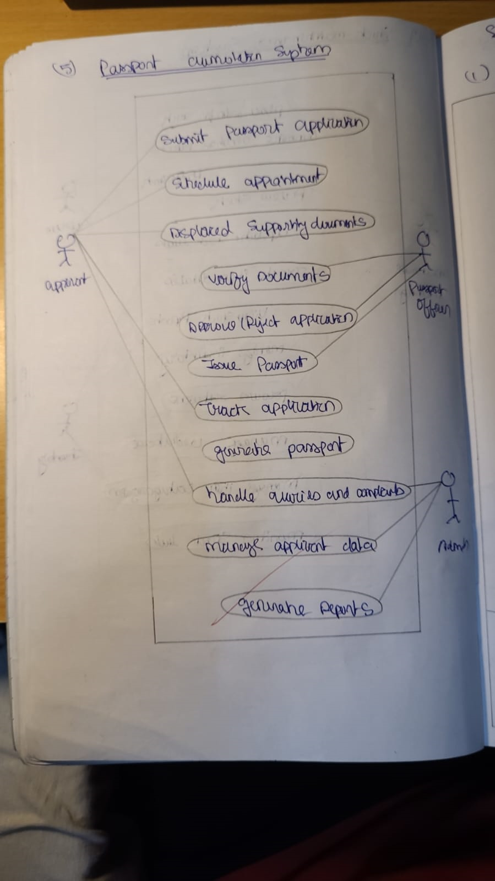

1. **INTERACTION MODELLING: SEQUENCE MODELS**

**Hotel Management System**

**Use Case: Book Room**

**Actors**: Guest, Receptionist, Hotel System  
**Objects**: Guest, Receptionist, Hotel System, Payment Gateway

**Sequence:**

1. **Guest → Receptionist**: Request to book a room.
2. **Receptionist → Hotel System**: Search for available rooms.
3. **Hotel System → Receptionist**: Return list of available rooms.
4. **Receptionist → Guest**: Provide room options.
5. **Guest → Receptionist**: Select room and provide details.
6. **Receptionist → Payment Gateway**: Process payment.
7. **Payment Gateway → Hotel System**: Confirm payment status.
8. **Hotel System → Receptionist**: Confirm booking and generate receipt.
9. **Receptionist → Guest**: Provide booking confirmation.

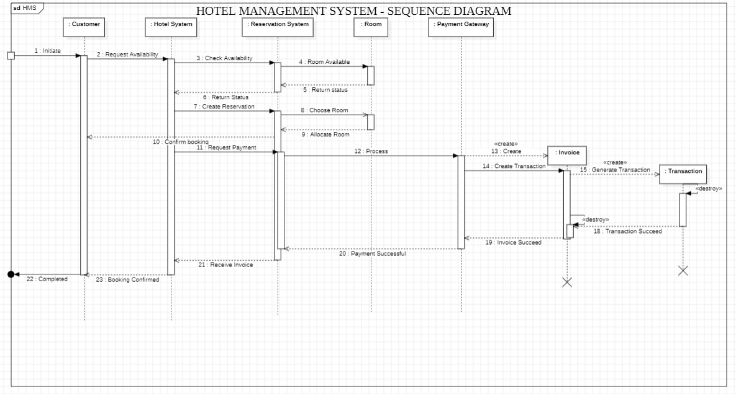

**Figure 5.1 – HMS Sequence Diagarm**

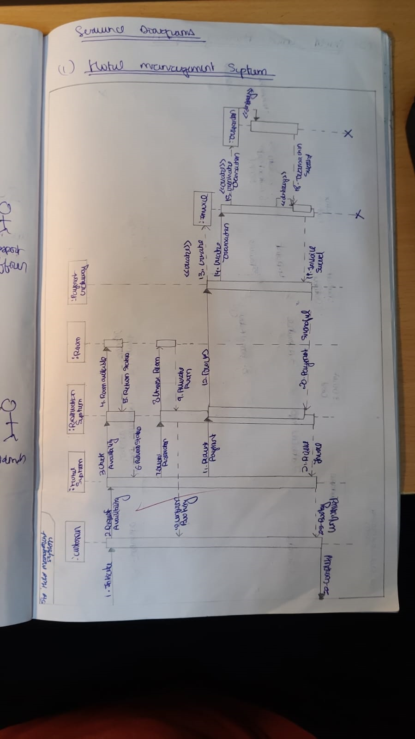

**Credit Card Processing System**

**Use Case: Process Payment**

**Actors**: Cardholder, Merchant  
**Objects**: Cardholder, Merchant, Payment Gateway, Bank

**Sequence:**

1. **Cardholder → Merchant**: Provide payment details.
2. **Merchant → Payment Gateway**: Forward transaction details.
3. **Payment Gateway → Bank**: Verify card details and funds.
4. **Bank → Payment Gateway**: Return authorization status.
5. **Payment Gateway → Merchant**: Confirm payment.
6. **Merchant → Cardholder**: Notify transaction result.

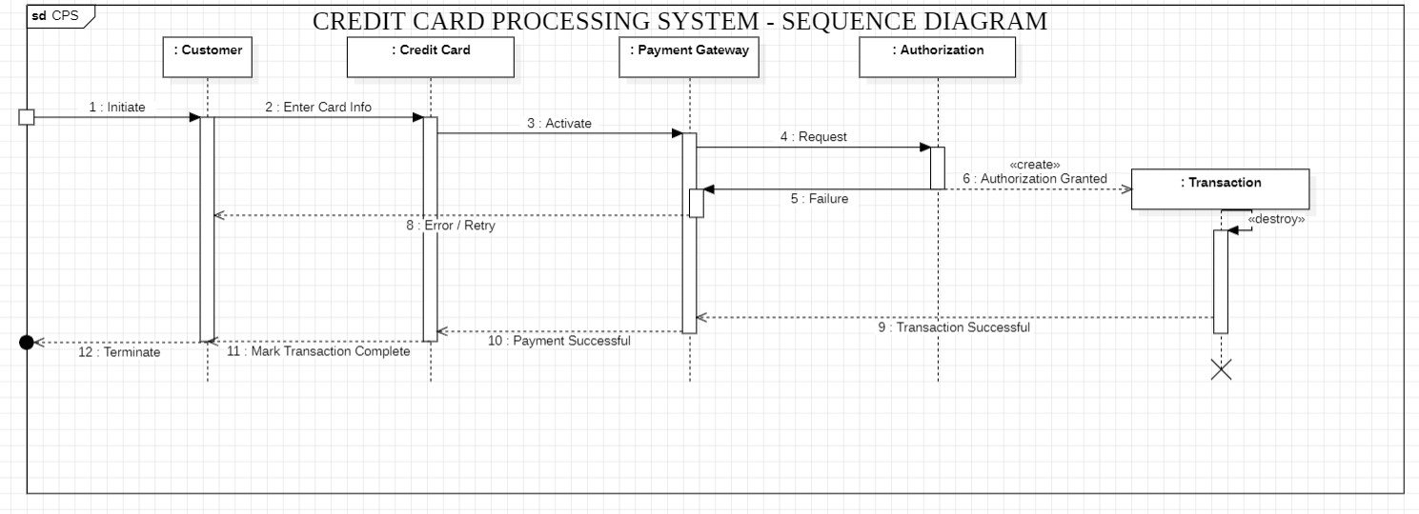

**Figure 5.2 – CCPS Sequence Diagram**

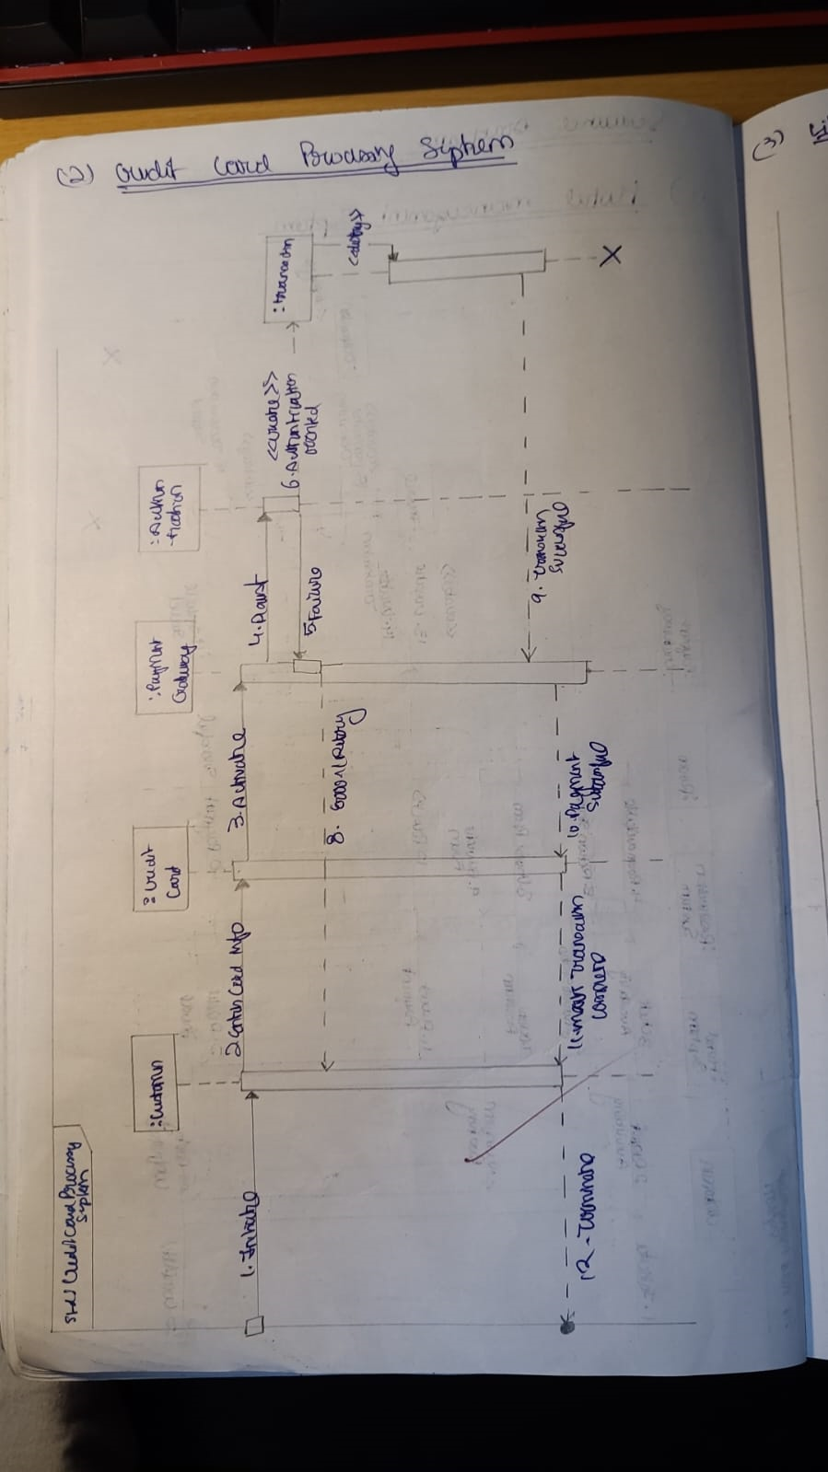

**Library Management System**

**Use Case: Borrow Book**

**Actors**: Member, Librarian  
**Objects**: Member, Librarian, Library System

**Sequence:**

1. **Member → Librarian**: Request to borrow a book.
2. **Librarian → Library System**: Check book availability.
3. **Library System → Librarian**: Return availability status.
4. **Librarian → Member**: Confirm loan and record due date.
5. **Library System → Member**: Update inventory and loan record.

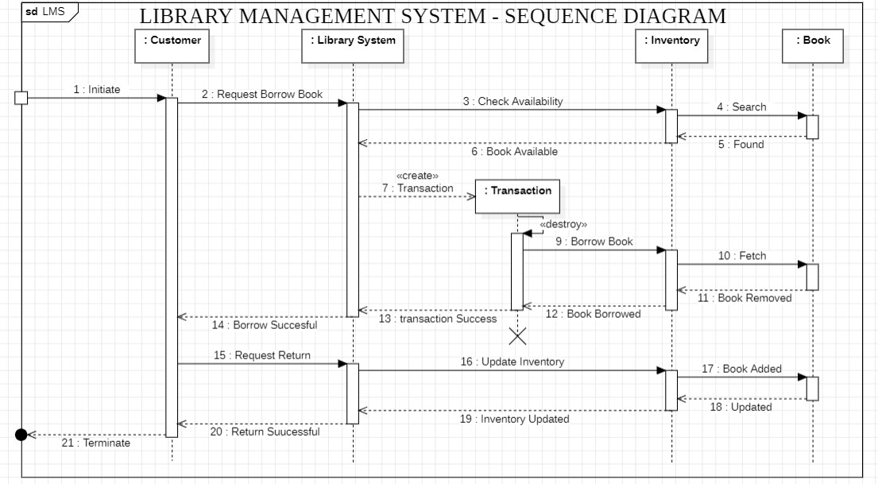

**Figure 5.3 – LMS Sequence Diagram**

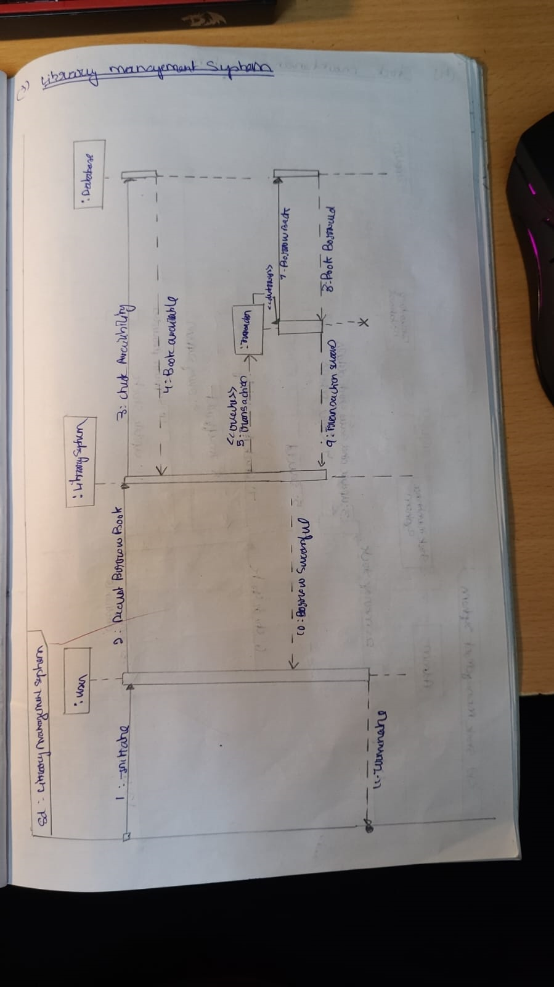

**Stock Maintenance System**

**Use Case: Monitor and Replenish Stock**

**Actors**: Warehouse Manager, Supplier  
**Objects**: Warehouse Manager, Inventory System, Supplier

**Sequence:**

1. **Inventory System → Warehouse Manager**: Notify low stock alert.
2. **Warehouse Manager → Supplier**: Place a replenishment order.
3. **Supplier → Warehouse Manager**: Confirm order and provide delivery date.
4. **Supplier → Inventory System**: Update stock levels after delivery.
5. **Inventory System → Warehouse Manager**: Notify successful restocking.

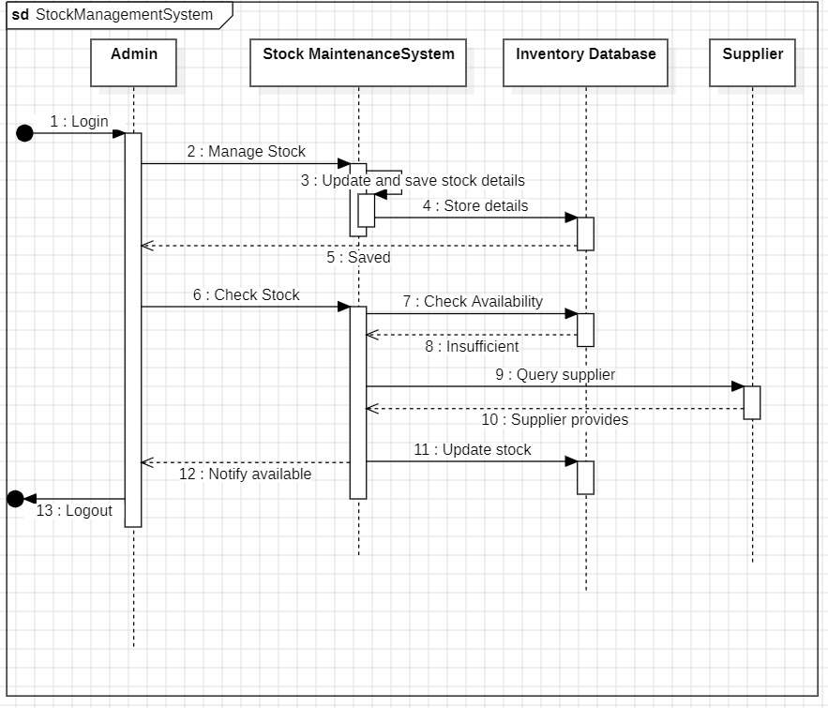

**Figure 5.4 – SMS Sequence Diagram**

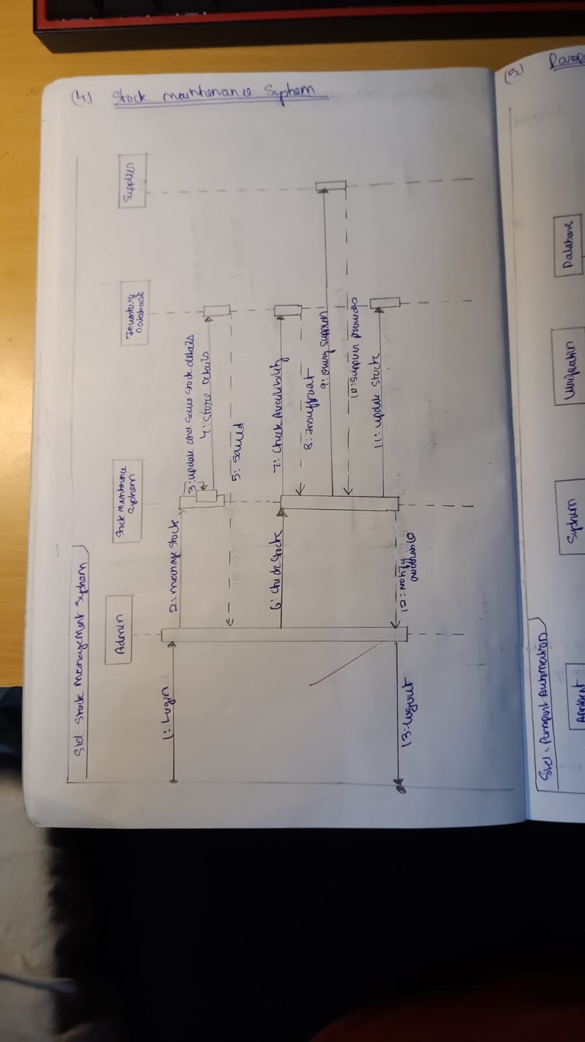

**Passport Automation System**

**Use Case: Submit and Process Application**

**Actors**: Applicant, Officer  
**Objects**: Applicant, Passport System, Officer

**Sequence:**

1. **Applicant → Passport System**: Submit application and documents.
2. **Passport System → Officer**: Forward application for review.
3. **Officer → Passport System**: Verify documents.
4. **Passport System → Officer**: Return verification status.
5. **Officer → Applicant**: Notify of application approval or rejection.
6. **Passport System → Applicant**: Issue passport if approved.

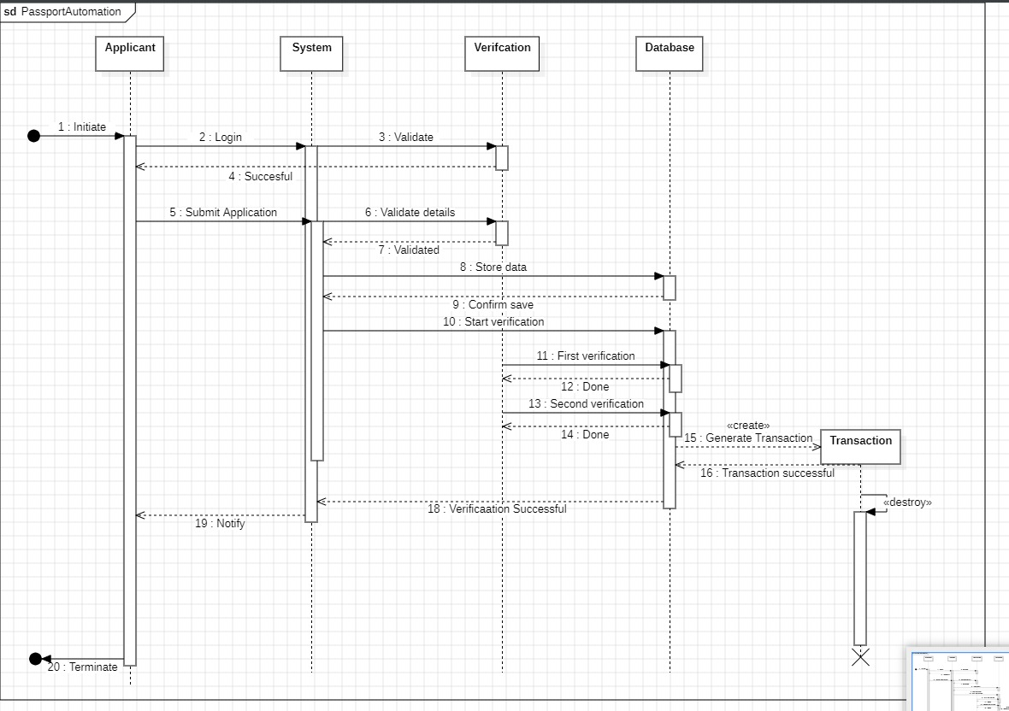

**Figure 5.5 – PAS Sequence Diagram**

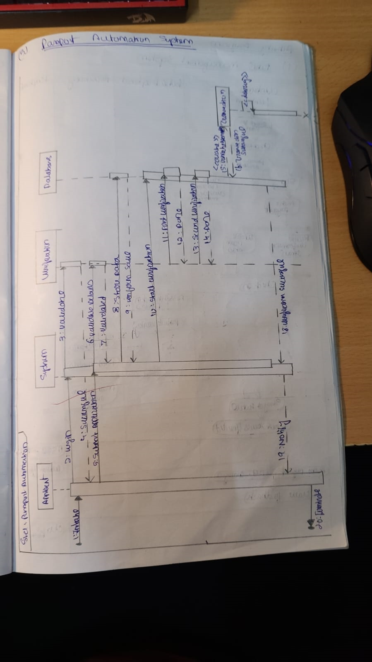

**6. INTERACTION MODELLING: ACTIVITY MODELS**

**Hotel Management System**

**Key Activities:**

1. **Start**: Guest initiates the booking process.
2. **Select Room**: Display available rooms.
3. **Enter Guest Details**: Input personal and contact information.
4. **Process Payment**: Validate and complete payment.
5. **Confirm Booking**: Generate booking confirmation.
6. **Check-In**: Assign room and provide key.
7. **Use Services**: Request and use additional services (optional).
8. **Check-Out**: Generate final bill and mark room as available.
9. **End**: Complete the workflow.

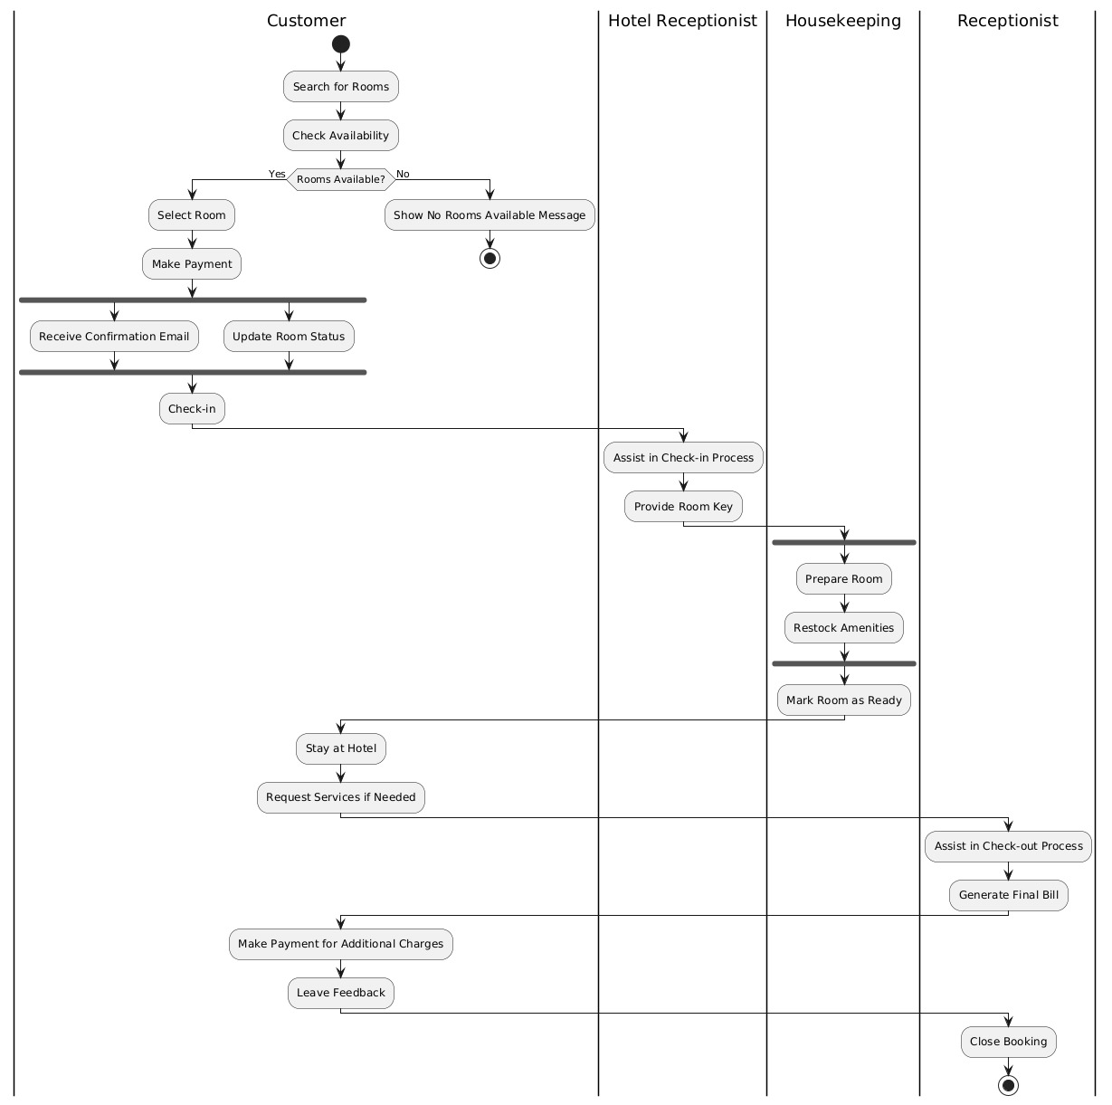

**Figure 6.1 – HMS Activity Diagram**

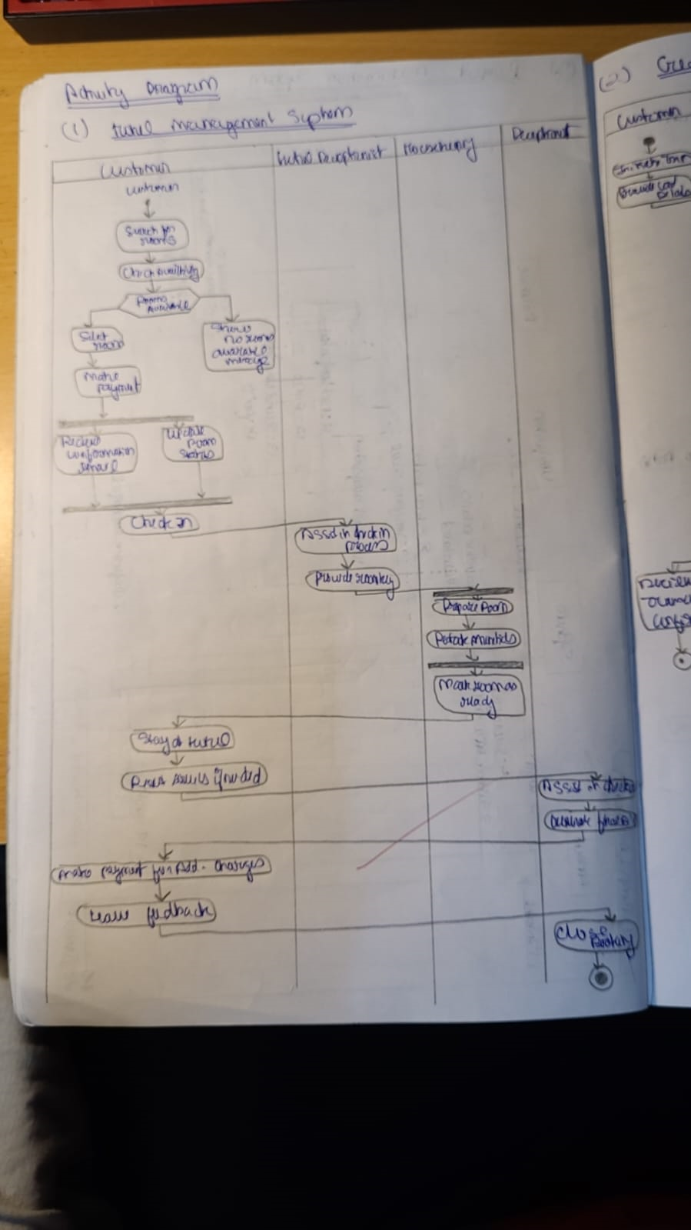

**Credit Card Processing System**

**Key Activities:**

1. **Start**: Cardholder initiates the transaction.
2. **Input Details**: Enter card and transaction details.
3. **Validate Transaction**:
   * Check card validity.
   * Verify funds availability.
4. **Decision**:
   * **If valid**: Proceed to authorization.
   * **If invalid**: Reject the transaction.
5. **Authorize Payment**: Secure confirmation from the issuing bank.
6. **Process Payment**: Complete the transaction.
7. **End**: Notify cardholder of transaction status.

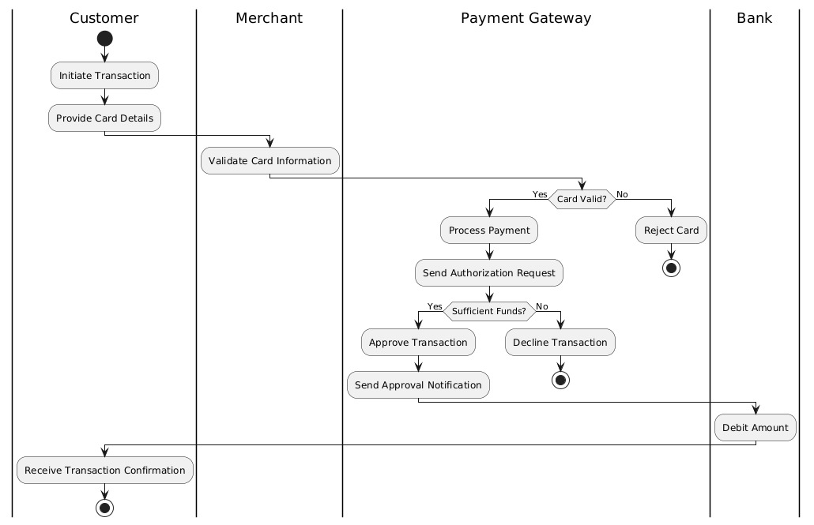

**Figure 6.2 – CCPS Activity Diagram**

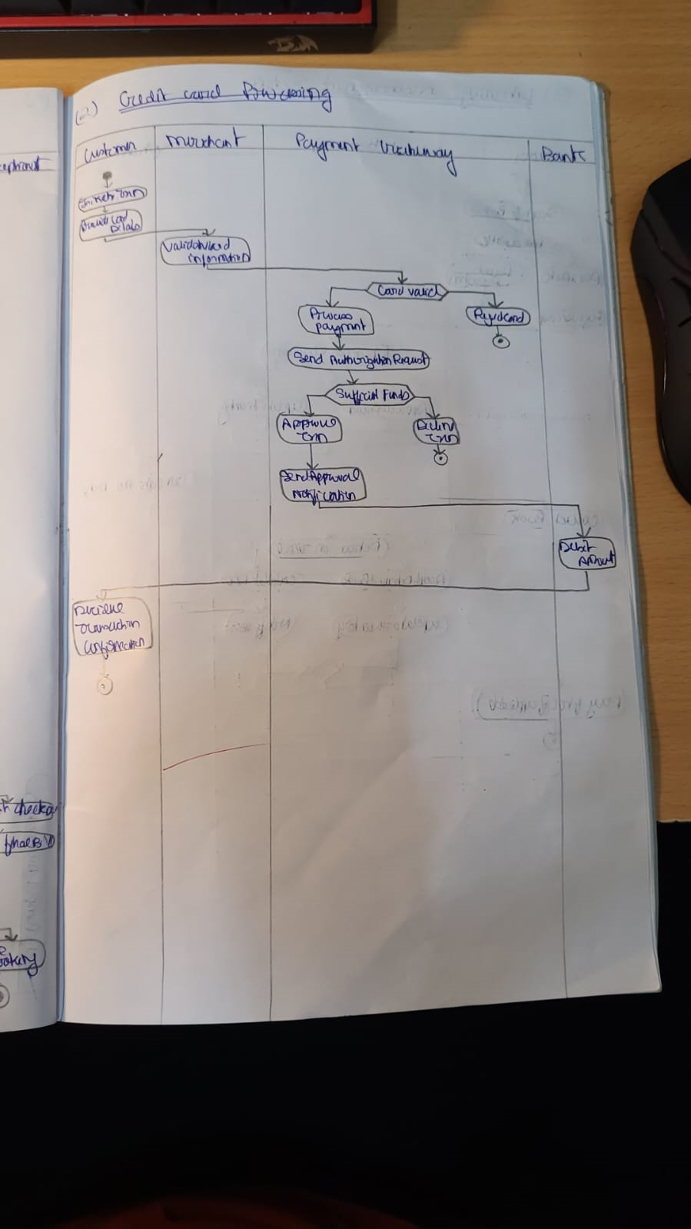

**Library Management System**

**Key Activities:**

1. **Start**: Member selects a book.
2. **Check Availability**:
   * **If available**: Proceed to loan.
   * **If unavailable**: Notify member.
3. **Borrow Book**: Record loan details and set due date.
4. **Track Loan Duration**: Monitor the loan period.
5. **Decision**:
   * **If overdue**: Notify member and calculate fine.
   * **If returned**: Update inventory.
6. **Pay Fine** (if applicable): Member clears overdue charges.
7. **End**: Complete the return process.

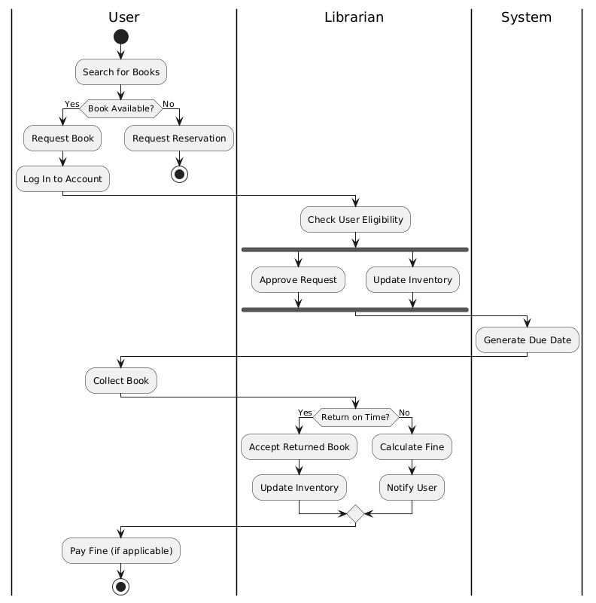

**Figure 6.3 – LMS Activity Diagram**

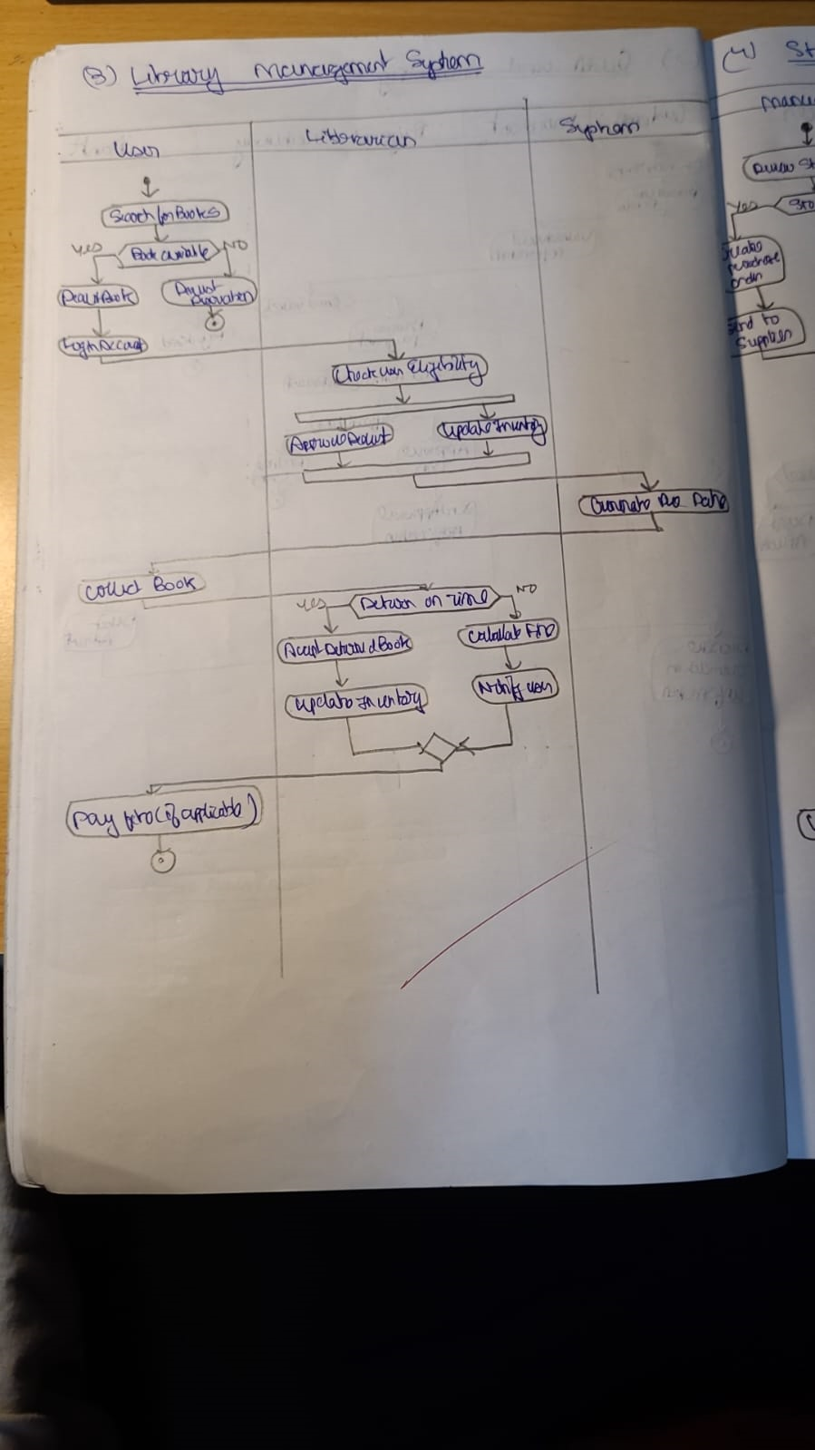

**Stock Maintenance System**

**Key Activities:**

1. **Start**: Monitor stock levels.
2. **Decision**:
   * **If sufficient stock**: Continue monitoring.
   * **If low stock**: Generate an alert.
3. **Place Order**: Initiate a purchase request.
4. **Receive Delivery**: Update stock levels.
5. **Restock**: Replenish inventory and notify stakeholders.
6. **End**: Complete the workflow.

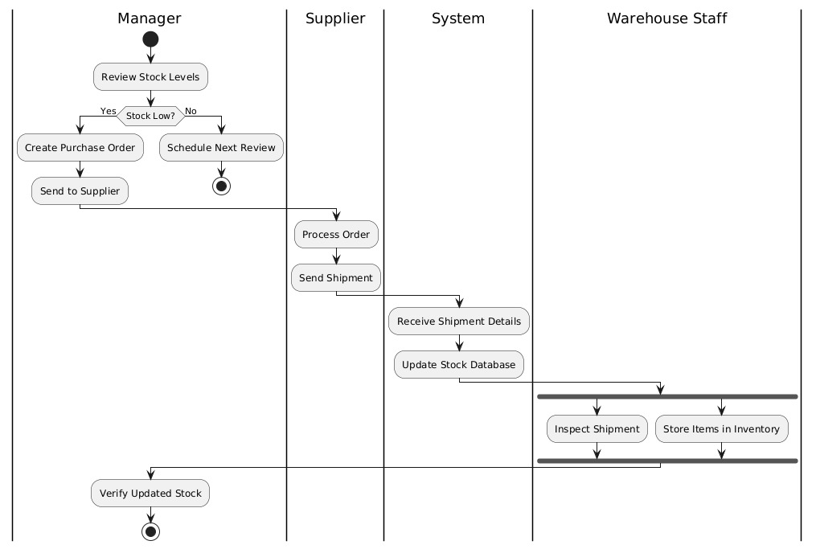

**Figure 6.4 – SMS Activity Diagram**

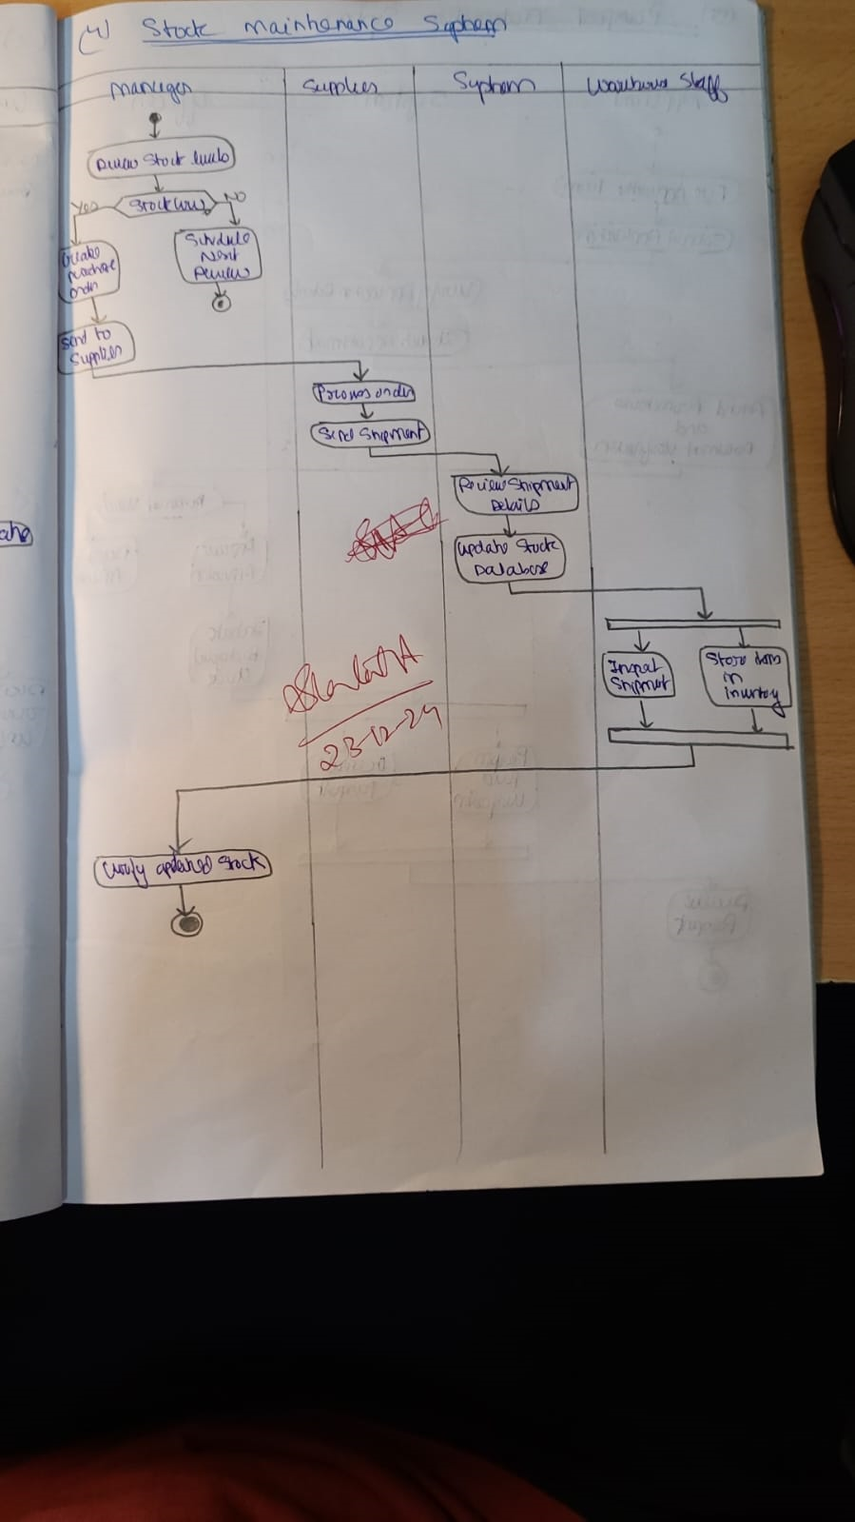

**Passport Automation System**

**Key Activities:**

1. **Start**: Applicant submits an application.
2. **Schedule Appointment**: Book a verification slot.
3. **Verify Documents**: Check the authenticity of submitted documents.
4. **Decision**:
   * **If valid**: Approve the application.
   * **If invalid**: Reject the application.
5. **Issue Passport** (if approved): Generate the passport.
6. **Notify Applicant**: Inform the applicant of the decision.
7. **End**: Complete the process.

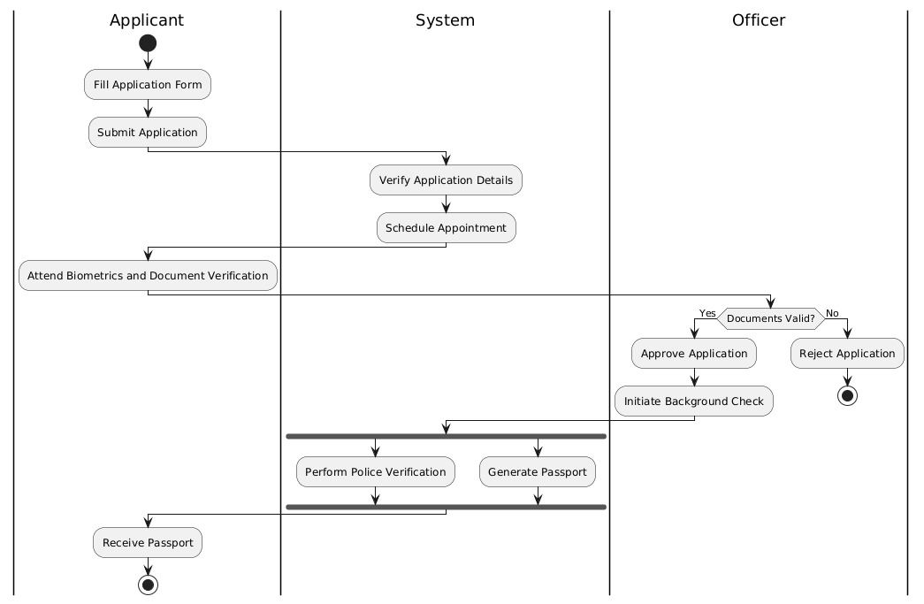

**Figure 6.5 – PAS Activity Diagram**

